Field Guide 1: Participatory Community Needs Assessments.
In community-based development, the development activities you want to work with are grassroots solutions for addressing community identified need. In this first community-based workshop you are going to use a Participatory Learning and Action (PLA) ranking tool. In the process workshop participants voice different problems, challenges and needs they experience in the community—and then vote on them with voting tokens (small stones or beans) to prioritize them. You will use drawings to illustrate community identified needs so that illiterate community members can equally participate in this process.

Workshop Preparation. Working with your community contacts, set up a three hour meeting with 10 or 12 community members two weeks or more in advance. Communities are diverse and you need to be sure that you are working with community members that represent the ultimate beneficiaries (mothers, fathers, families, farmers, weavers—whoever best describes the community you are intending to work with). Avoid basing your assessment on a meeting with people in higher positions: mayors or city council members for example. It is important that women and marginalized members have a voice in the process.

Each subgroup will have their own set of needs; some members may even be self-serving. Ensure that everyone in the workshop is given an equal chance to voice the challenges that they see in the community. If there are cultural norms which may prevent some participants from speaking out, you may elect to form two groups out of the group of participants—for example one of women separate from one of men—so that women can feel comfortable participating in the discussion. You could choose to hold a separate assessment with marginalized members of the community so they will feel comfortable speaking.

Review the lesson plan with your team and adapt the activities so they are specific to your community context. You may choose to produce an illustrated handout or poster for the workshop—especially if some participants can’t read. Role-play the activities with your colleagues so that you are better prepared for presenting the workshop, and so you can discover if there are any cultural or linguistic problems. In the workshop you need to be simply a facilitator and not color the needs assessment with your own preferences.

Make sure that you have all of the materials that you may need such as notebook paper, large sheets of newsprint, tape, and markers for drawings. Since this is a three hour workshop you may also need to plan snacks and drinks. Have two to three colleagues accompany you to help. This will be especially useful if you decide to break the participants down into sub-groups. If you are considering providing snacks put someone in charge so that you aren’t distracted with the details and are free to focus completely on facilitating the workshop.

Community need from the community perspective. After initial rapport building with the group, explain that the purpose of the activities is to understand and learn about their community from their perspective. Ask the group to imagine and discuss the problems and needs that are faced by the community as a whole.

As each need is identified by a community member, begin making simple illustrations that represent their challenges on notebook sized sheets of paper (you can bring a selection of typical drawings to reduce time spent drawing). An example could be that if there is a housing shortage, draw a little house. After the group has come up with a complete set of needs/problems, arrange the different illustrations side-by-side into a rectangle on the ground or on a table.

Prioritizing need democratically. Have everyone leave the workshop area. Give each one of the participants voting tokens—10 or 15 slips of paper, beans, or grains of corn. For privacy during voting, only one person should go into the workshop area at a time to vote. They should select the needs which they feel as an individual are the most important. It is their decision if they want to put all 10 tokens on one drawing or if they want to distribute them around several different challenges.

Results matrix. When the participants have finished voting, count the total tokens on each drawing and write up a prioritized list ordered by the number of votes each problem received—with the need that received the most votes at the top. This would be a good time for the participants to take a break so that you can take a few minutes alone with the list and to draw a two column matrix on a sheet of newsprint that everyone can see. In the left column write down the individual needs in their prioritized order (or draw little pictures again) and in the right column write the number of votes each one received.

This is a good time for the participants to have an open discussion about the results of the vote. Plus, if there are any unrelated needs competing for the highest position it would be a good idea to let the participants do a second prioritization. For example there might be two health-related challenges near the top and two microenterprise challenges near the top as well. You can ask community which would be the first project they would like to start with—health or micro enterprise—so that you can keep your project simple and not be faced managing two dissimilar programs at once.

Selection of most important needs for project development. It's very likely that the list will be a disorganized mixture of needs, challenges, underlying causes and grievances. Work with the group to connect challenges to their underlying causes on the matrix so that they can see the relationship. If the matrix doesn't have any underlying causes this would be a good time to ask the participants what they feel the causes of the top priority challenges are. It's likely that they might have more background information about a problem than you do—so this can be quite helpful. This is a good time to discuss potential solutions which they may see and what local coping strategies they are already using.

Community feedback and verification. Conclude the meeting by summarizing the two or three challenges that the community placed as their highest priorities and their relationships with underlying causes. Ask for feedback of your summary in order to get verification from the participants. Use your best facilitation skills to make sure that no one has any questions or further comments.

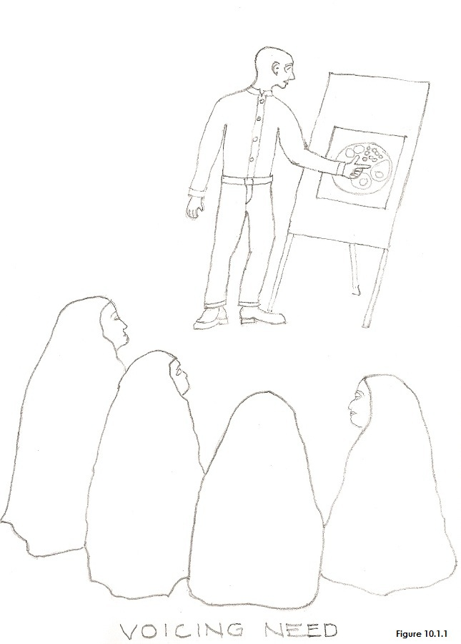 | 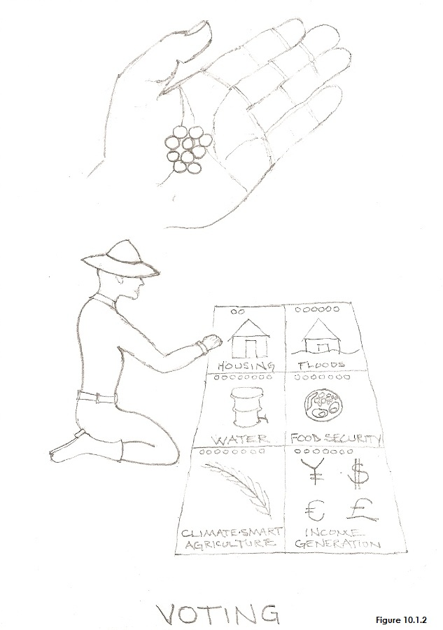
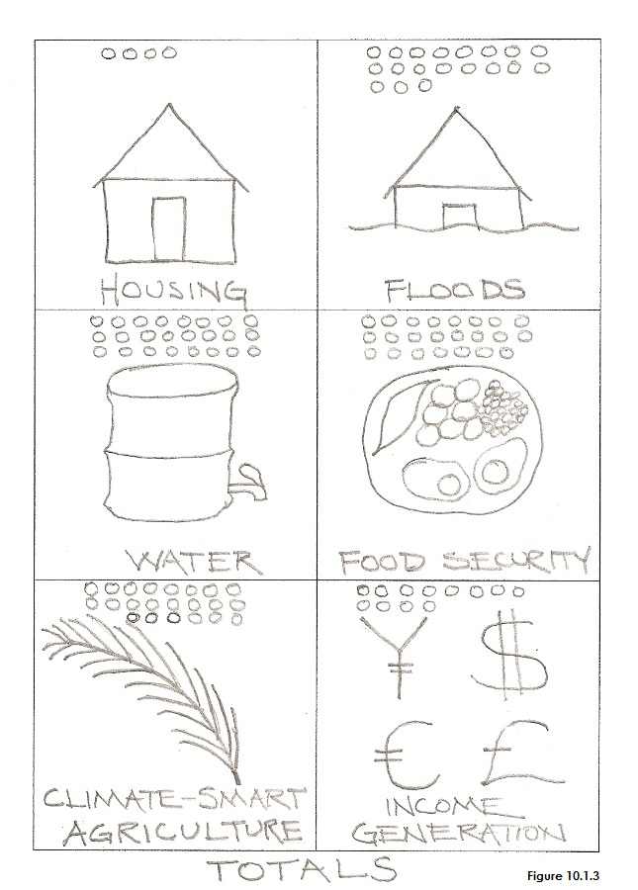 | 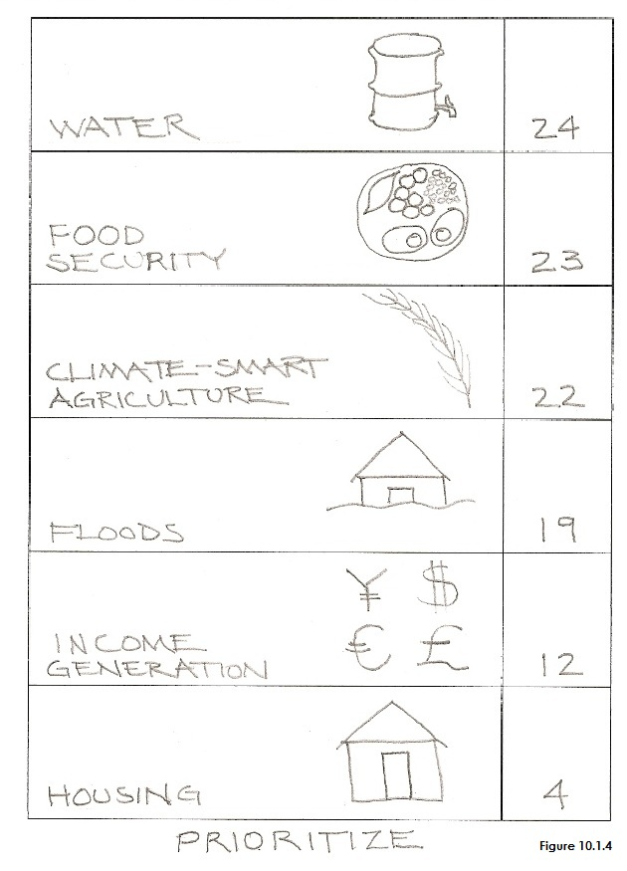

Field Guide 1: Workshop Lesson Plan on Participatory Community Needs Assessment.
Duration of Workshop: 3 hours

BACKGROUND FOR LESSON PLAN
Assumed Knowledge
The community has agreed that a community needs assessment will be beneficial.

Anticipated Difficulties/Problems
- Information may not be well received due to cultural differences between workshop leaders and participants.
- Community members may be resistant to behavioral changes.
- Strong personalities may dominate workshops.
- Stakeholders with vested interests may want a needs assessment favorable to them.

Solutions
- It is important that the facilitator is from a similar culture and speaks the same language as the participants.
- Drawings and illustrations should be appropriate for and familiar to the community members.
- Strong personalities may be able to be reasoned with in order to understand the importance of the participatory process, given projects that will occupy them, or taken aside for a VIP interview.

PURPOSE: What workshop participants will be able to do as a result of the lesson.
The purpose of the workshop is for community members to assess and to prioritize needs within their community.
- Participants will work in an environment where they feel safe discussing community needs and developing a needs list.
- Participants will use drawings to identify needs so that illiterate members will be able to participate.
- Participants will agree upon a prioritized needs list most appropriate for the community.

MATERIALS
- Large sheets of newsprint.
- Notebook sized paper.
- Colored pens or markers.
- Sticky tape.
- About 15 drawings of community needs traditionally identified by community members.
- Beans, slips of paper or grains of corn for voting tokens.

BEGINNING OF LESSON:
Activity 1. Introduction

Purpose
- To help build a feeling of team spirit and mutual understanding. To generate group self-esteem and creativity.
- To understand the purpose of the workshop.

Time: 1/2 hour

What to do
Introduction:
- Introductions. Ice Breaker: Sing a song or play a game.
- Tell the participants what they’ll be able to do as a result of the lesson. Use the how-to card or a poster to visually show them the process:
  - Discuss community need.
  - Vote on the needs.
  - Total the votes.
  - Prioritize the needs.
  - Discuss underlying causes and potential solutions.

GUIDED PRACTICE:
Activity 2. Open discussion about Community Need and Prioritizing Challenges and Needs.

Purpose : Participants will openly discuss problems and needs within the community.
Time: 1 1/2 hours
What to do
Guided Practice
- Ask the group to imagine and discuss the challenges and needs faced by the community.
- As each need is identified by a community member, begin making simple illustrations that represent the challenges on notebook sized sheets of paper (you can bring a selection of typical drawings to reduce time spent drawing).
- After the group has come up with a good set of needs/problems, arrange the different illustrations side-by-side into a rectangle on the ground or on a table.
- Have everyone leave the voting area and give each individual in the group 10 or 15 beans, slips of paper or grains of corn.
- Ask them to place the voting tokens on the challenges they feel are the most important. It is their decision if they want to put all 10 tokens on one drawing or if they want to distribute them around several different challenges.
- When the participants have finished voting, count the total tokens on each drawing and write up a prioritized list ordered by the number of votes each challenge received—with the need that received the most votes at the top. This would be a good time for the participants to take a break so that you can take a few minutes alone with the list and to draw a two column matrix on a sheet of newsprint that everyone can see. In the left column write down the individual needs in their prioritized order (or draw little pictures again) and in the right column write the number of votes each one received.

BREAK: 15 MINUTES

Activity 3. Discovering Underlying Causes to Problems and Needs
Purpose: Participants will discover underlying causes to problems to challenges and needs.
Time: 1 hour

What to do
Guided Practice
- Review the results of the prioritized matrix with the group.
- Ask them if the top items on the prioritized list represent the needs that are most important for the community.
- If there are competing items at the top of the priority list asked them to choose the ones that they would like to include in the first project.
- Can they determine the underlying causes of the problems? List these underlying causes beneath the prioritized challenges that will be focused on during the first project. Frequently underlying causes are already on the priority list—simply move them into position beneath the top priorities.
- If the matrix doesn't have any underlying causes this would be a good time to ask the participants what they feel the causes of the top priority challenges are.
- Discuss potential solutions which they may see and what local coping strategies they are already using.

Workshop Participants:
Take 5 minutes to discuss the prioritized list, the problems chosen with the highest priority, and the underlying causes. Have participants talk about what they do and don’t understand, what they do and don’t like.

CONCLUSION:
Activity 5. Conclusion
Purpose
To reinforce what has been learned.
Time: 30 Minutes

What to do
Guided Practice
- Discuss and review what has been learned and decided.
- Summarize the two or three challenges that the community places as their highest priority.
- Discuss the relationship between the challenges and their underlying causes.
- Review potential solutions to the community’s challenges.
- Ask the group to ensure the validity of the summarized information.
- Make sure that there are no more questions and that everyone understands what happened in this process.

Copyright © Tim Magee

