Student Title: Magee, OL 342 Assignment Six
Date: Date of Student Assignment Here
Magee Example Project Assignment 6
OL 342 Project Architecture: Planning for Impact.
https://csd-i.org/ol-342-adapting-climate-change/

Assignment Six. How will you organize your ideas for presentation to a donor?
Part 1.
When I visit donors, I like to carry along a presentation book (that I keep), and a few loose documents that they can keep. So, what I did this week is that I collected 12 week’s worth of my own assignment examples and had them bound into a presentation book.

I can use this presentation book in a meeting with a potential employer, in a meeting with my boss when I'm looking for raise, or in a meeting with a donor when I hope to impress them with the quality of my work.

So I took my assignments, made sure that I cleaned them up so that they look good, and printed them out carefully. I also collected a few of my best photographs of the community that I worked with.

On the front cover I purchased a piece of card stock for printing the photographs on. I simply laid the photographs out in a Microsoft Word table and put a nice project title across the top.

I then went to the local photocopy store and paid another two dollars to have it bound with a clear plastic cover and metal spiral.

Inside, I have my week one summary of the community defined needs and simple project outline, and then week two’s expanded outline with proposed activities.

Next I have examples of my research on evidence-based solutions to our problem statement.

Then I show how I plan to share all of this information with my community: a short field guide, a lesson plan for presenting a community workshop, and an example of a how to card that workshop attendees can take home.

Since my presentation book isn’t just for the assignment’s donor meeting, potential employers, bosses, and other donors will also be impressed with the well-developed log frame. This will assure them that I very carefully thought through the project and have determined in fine detail what I need to do to fulfill the main project goal.

They will also be interested to see that I've put together a long-term impact statement – and a monitoring and evaluation plan – complete with indicators and means of verification. They will be relieved by my transparent, detailed budget.

The first thing that I'm going to show the donor, however, is my two page compelling fact sheet which summarizes our 12 weeks of project development in a compelling storyline that brings our project to life.

They can scan this two page sheet for 30 seconds and see in a heartbeat what the project is about. As their interest grows I can flip through my presentation book and show them the background data that supports the project.

Whether this is a potential employer, a current boss, or a potential donor, a presentation book like this has frequently made my meetings successful. Sometimes people in meetings will ask if they can ‘borrow’ it; my experience is that I never see my book again.

In summary the presentation book of this course shows how we have built sustainability and impact into the project, it shows how we’re going to manage the project successfully, and it gives our audience a sense of our capabilities.

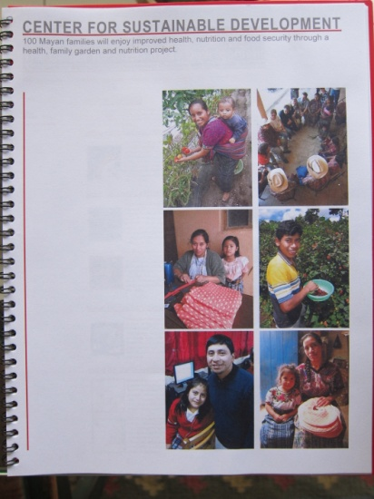 | 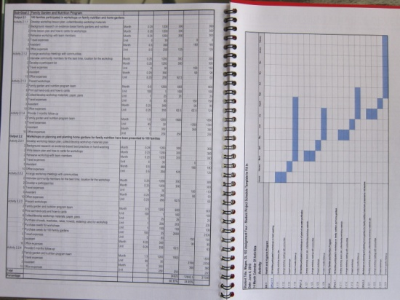 | 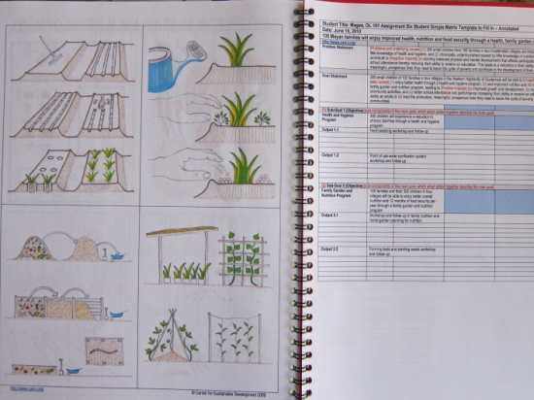

Part 2. Sharing your project with a donor.
Last week, I had made an appointment with a potential donor/partner:
Schuyler Thorp, Regional Director, Latin America and the Caribbean, Catholic Relief Services and Anne Bousquet, Guatemala Country Director for Catholic Relief Services.

Schuyler, and Anne had discussed the gardening project that I showed them in January. They feel that we might be able to partner on this project. He said that they had been wanting to improve their home garden program, and perhaps they could fund us to do it. They said that they were encouraged by the progress that the design of the project had taken in the past two months.

I feel good that I got positive feedback. CRS is an organization committed to grassroots projects and showed interest in partnering.

Tim Magee

Copyright © Tim Magee

