Field Guide 2: Participatory Capacity and Vulnerability Assessment
Center for Sustainable Development https://csd-i.org/ol-343-the-community-focus/
Schedule a workshop with the community for six hours. You can also do this workshop in two, three hour sessions.
Activity 1. 1 1/2 hours. Seasonal calendar

This first activity in the workshop will be drawing a seasonal calendar in the form of a matrix. Draw a matrix on a sheet of newsprint—or several sheets taped together. On this calendar you’re trying to establish relationships between times of the year, seasonal events, and special events that happen in the community.
- the rainy season; the dry season
- periods of drought
- extreme weather events
- flooding
- important livelihood activities
- disease
- periods of hunger
- planting and harvesting

Along the top axis, you can write the initials for the 12 months of the year. So that all workshop participants can engage in the activity you can make it very visual by drawing little symbols—such as planting corn—so that non-readers will be included. Along the vertical axis on the left you can begin writing down the events that community members describe. Then, adjacent to the event you can make a mark in the appropriate months that the event occurs. One helpful technique is to have a second piece of newsprint that you can quickly write down ideas as the community comes up with them. This will give them the freedom to speak openly and quickly if they like. After a good number of ideas have been voiced, you can organize the ideas and the key events—since many of the individual ideas may be related or just phrased in a different manner. After having organized the events, you can then add them to the clean version of the calendar.

When everyone is satisfied that the calendar is accurate, introduce the following questions:
- Are the hazards concentrated in one time period?
- Are there time periods in the year which are the most difficult for community members and for their livelihoods?
- What are the community members’ current coping strategies for dealing with these difficult periods?
- Capacity building: Which of the difficult periods are they having trouble coping with due to a lack of strategies?

Activity 2. 1 1/2 hours. Hazard mapping

The second 1 ½ hour activity in the workshop will be drawing a participatory hazard map of the community. Participatory mapping is a tremendous tool because all workshop participants can engage in the activity since it's very visual—non-readers will be included. Consider returning to the village the day before the workshop to tour the farm fields, forests, and water sources with one of the villagers. Take a few minutes to talk to farmers you meet in order to gain a greater understanding of the challenges they are facing.

Focus the exercise on drawing a community map on a sheet of newsprint—or several sheets taped together—in order to understand the spatial relationships between the different parts of the community. On this first map you’re trying to establish relationships between major community components. How the village relates to the farm fields, hills, roads and where sources of water are.

When everybody at the workshop is satisfied that the basic map represents the community, farming areas and surrounding environmental resources, you can begin marking things on the map such as where individual's homes are, or where their farm fields are. It's a good idea to represent buildings and farmer's plots using pieces of colored paper that can be attached to the map with removable tape so they can be moved or adjusted.

When everyone is satisfied that the map is accurate, introduce the idea of hazards that the community either suffers from or is at risk of suffering from in the future. These hazards could include areas affected by extreme weather events, floods, heavy rainfall, drought and health challenges. Once the hazard prone areas have been indicated on the map raise the following questions:
- Are the hazards concentrated in one area of the community?
- What negative impacts will the hazards have on community members and their assets?
- Who in the community is the most at risk from the hazards?
- Are there safe places in the neighborhood where community members can shelter from the hazards?

Note:
- What are the community members’ current coping strategies for dealing with these difficult events?
- Capacity building: Which of the difficult events are they having trouble coping with due to a lack of strategies?

Activity 3. 1 1/2 hours. Historical timeline

The Historical Timeline is one that is a very simple matrix with years in the left column and important events in the right column. You are looking for insights into past hazards and events, and how they may have changed, intensified, or become more frequent over time.

These could include hurricanes, droughts, epidemics, famines or floods. Other examples could include storms, erratic rainfall, a change in the timing of the growing seasons and water availability. Hopefully, there will be village elders in the workshop that will allow you to get a long-term perspective from 20 or 25 years ago so that you and the villagers can see if these events are occurring more frequently.

Next, when the group has completed the timeline, introduce the subject of climate change into this timeline. Have they seen a change over time with changes in climate? When did they start noticing the changes? Some examples:
- beginning 20 years ago rainfall began diminishing; by how much?
- beginning 20 years ago, the growing season changed; its shorter now—or it starts later.
- beginning 20 years ago, the number of storms have increased and there is flooding when there didn’t used to be.
- beginning 20 years ago, they've had to walk progressively further to get water. How much further?

Briefly describe the changes they have seen, how they've changed and over what time frame. Does the community realize this is linked to climate change and realize that this may be ongoing and intensifying?

Note:
- What are the community members’ current coping strategies for dealing with these difficult challenges?
- Capacity building: Which of the challenges are they having trouble coping with due to a lack of strategies?

Activity 4. 1 1/2 hours. Matrix: Impact of hazards on livelihood assets and resources

The Vulnerability Matrix is another very simple matrix with important livelihood resources and assets in the left column and important hazards in the first three activities in the top row. It's a good idea to prepare a blank matrix on newsprint in advance. Doing a preliminary matrix on a sheet of notebook paper is also a good idea—you can then just organize and transfer the information onto the clean, blank matrix.

INSERT TABLE 10.2 NEAR HERE

Table 10.2. Typical assets, resources and hazards
Important assets and resources may include:  - income generation from agriculture  - crop land  - livestock  - irrigation systems  - health  - food reserves/food security  - environmental resources such as forests and water | Typical hazards may include:  - extreme weather events such as hurricanes or cyclones  - drought/heat waves  - unpredictable beginning and end to the rainy season  - erratic rainfall or more or less rainfall  - lack of water  - shortage of food at specific times of the year  - flooding  - change in the timing of the growing season  - health issues/disease

Once the matrix has been drawn with what the community feels are the most important hazards along the top row and assets and resources which are the most vulnerable along the left column ask them to rank in terms of importance which hazards are having the greatest impact on which resources. There are two ways that you can do this. Much like with needs assessment, you could give each participant 15 counting stones, lay the matrix on the floor and let them vote. Or, you can hold a discussion and let them rank the importance of hazard impact on resources and mark it on the matrix.
3 = greatest impact on the resource
2 = median impact on the resource
1 = low impact of the resource
0 = no impact of the resource

Please note what hazards they are facing and prioritize them by which are the most challenging for them. Note which areas they feel the most vulnerable in and prioritize them.

At the end of this exercise you will have a matrix that prioritizes which hazards are causing the greatest risk and vulnerability for which livelihood assets and resources. As a concluding exercise, discuss this prioritization with the participants and make sure that they are an agreement.

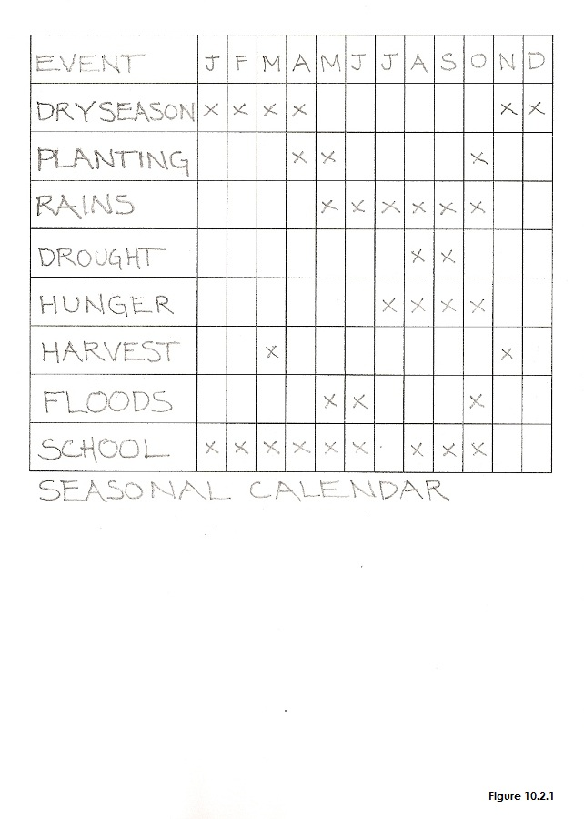 | 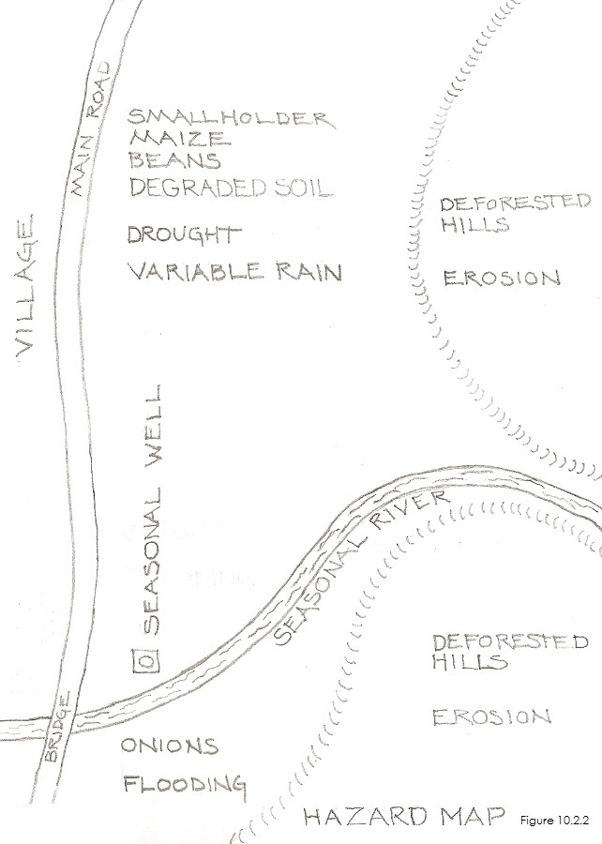
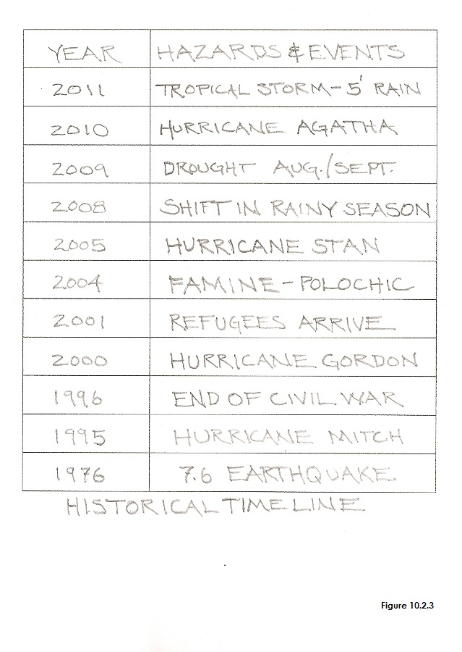 | 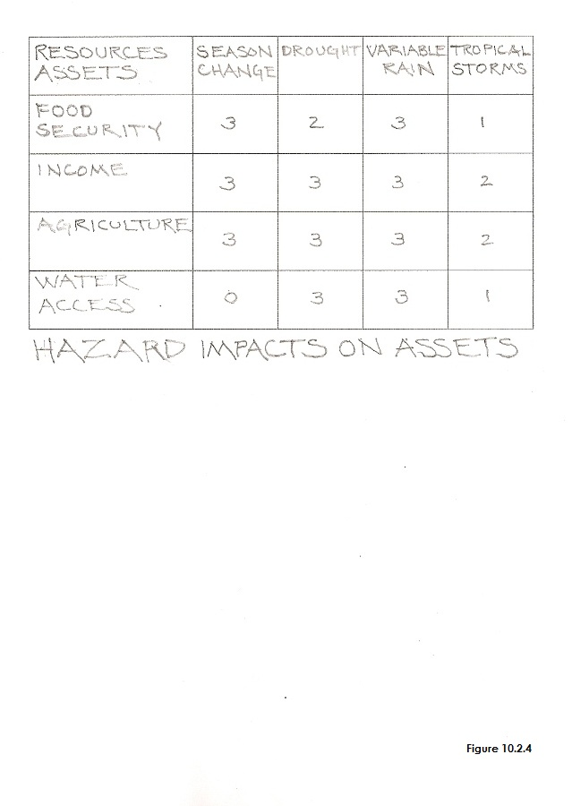
INSERT FIGURES 10.2.1, 10.2.2, 10.2.3, and 10.2.4, NEAR HERE

Field Guide 2: Workshop Lesson Plan for a Participatory Capacity and Vulnerability Assessment
Duration of Workshop: Six hours plus a lunch break. You can also do this workshop in two, three hour sessions
Assumed Knowledge. The community has agreed that a vulnerability assessment will be beneficial.
Purpose: Participants will understand which hazards are causing the greatest risk and vulnerability for which livelihood assets.

MATERIALS
- Large sheets of newsprint.
- Colored pens or markers.
- Sticky tape.

BEGINNING OF LESSON:
Introduction: 15 Minutes
Introductions. Ice Breaker: Sing a song or play a game.
Statement of Purpose: Tell the participants what they’ll be able to do as a result of the lesson. Show them the how-to card so they can see the entire process.

Activity 1. 1 1/2 hours. Seasonal calendar
Purpose: On this calendar you will be establishing relationships between times of the year, seasonal events, and special events that happen in the community.

What to do. Draw a matrix on a sheet of newsprint. Along the top axis, write the initials for the 12 months of the year. Along the vertical axis on the left you can begin writing down the events as community members identify them. Then, adjacent to the event make a mark in the appropriate months that the event occurs.

Guided Practice
- Ask the group to imagine and discuss important events that happen during the year in their community. These could include the agricultural season, the rainy season and dry season, extreme weather events, periods of hunger and periods of illness. It can also include community events such as the school year and annual festivals.
- Once the calendar is complete ask about periods of hazards such as flooding. Ask the following questions:
- Are the hazards concentrated in one time?
- Are there time periods in the year which are the most difficult for community members and their assets?

What are the community members’ current coping strategies for dealing with these difficult periods?
Capacity building: Which of the difficult periods are they having trouble coping with due to a lack of strategies?

BREAK: 15 minutes

Activity 2. 1 1/2 hours. Hazard mapping
Purpose: Participants will discover spatial relationships between different components in the village and how hazards impact different areas and groups of people in the village.

What to do. Consider returning to the village the day before the workshop to tour the farm fields, forests, and water sources with one of the villagers. Take a few minutes to talk to farmers you meet in order to gain a greater understanding of the scale of the community and to get a better sense of some of the challenges they are facing.

Tape several sheets of newsprint together and place them on the floor. A suggestion is to begin with black to draw the basic outline of the village, roads, pathways, and major farming areas. You can then use different colors for houses, rivers, and farm fields.

Guided Practice
- Another suggestion is to take 15 minutes and have community members draw a small preliminary map of the village, surrounding farm fields, roads and pathways, farm fields and watersheds on a single sheet of newsprint. This will give you two things: you might discover that there is a good illustrator in the group—and you can quickly solve spatial problems by adjusting lines.
- Let your group artist transfer this basic outline of the community onto a larger piece of taped together sheets of newsprint.
- Take colored sheets of paper and cut them out to represent additional features. These could be individual farm fields, they could be houses, schools and churches—and stick them to the map with removable tape.
- When everyone is satisfied that the map is accurate, introduce the idea of hazards that the community suffers from. These hazards could include extreme weather events, floods, heavy rainfall, drought and health challenges. Once the hazards have been indicated on the map introduce the following questions:
- Are the hazards concentrated in one area of the community?
- What negative impacts will the hazards have on community members and their assets?
- Who in the community is the most at risk from the hazards?
- Are there safe places in the neighborhood where community members can shelter from the hazards?

What are the community members’ current coping strategies for dealing with these difficult periods?
Capacity building: Which of the difficult events are they having trouble coping with due to a lack of strategies?

LUNCH: 30 Minutes

Activity 3. 1 1/2 hours. Historical timelines
Purpose: You are looking for insights into past hazards and events, and how they may have changed, intensified, or become more frequent over time.

What to do. Draw a very simple matrix with a column for years on the left, and a column for important events on the right. Ask some of the elders of the group about a major event that occurred in the community—and what year it was. These could include hurricanes, droughts, epidemics, famines or floods. Hopefully, there will be village elders in the workshop that will allow you to get a long-term perspective from 20 or 25 years ago so that you and the villagers can see if these events are occurring more frequently.

Guided Practice
- Ask the group if they can remember major disasters that have happened over the past 25 in 30 years—and the year.
- Begin organizing a matrix by year and event. A preliminary matrix can be drafted and then transferred.
- When the group has completed the timeline, introduce the subject of climate change. Have they seen a change over time with of changes in climate? When did they start noticing the changes? Some examples:
- beginning 20 years ago rainfall began becoming less; by how much?
- beginning 20 years ago, the growing season changed; its shorter now—or it starts later.
- beginning 20 years ago, storms have increased and there is flooding when there didn’t used to be.
- beginning 20 years ago, they've had to walk progressively further to get water. How much further?

Briefly describe the changes they have seen, how they've changed and over what time frame. Does the community realize this is linked to climate change and realize that this may be ongoing and intensifying?

What are the community members’ current coping strategies for dealing with these difficult events?
Capacity building: Which of the difficult events are they having trouble coping with due to a lack of strategies?

BREAK: 15 Minutes

Activity 4. 1 1/2 hours. Matrix: Impact of Hazards on Livelihood Assets and Resources.
Purpose: To determine which community assets and resources are the most vulnerable and to determine which hazards are having the greatest impact on which resources.

What to do. Draw a simple matrix with livelihood resources and assets in the left column and hazards in the top row.

Guided Practice
- Ask the group to name the most important hazards as identified in the past three exercises. Place those in the top row
- Ask the group to name their most important livelihood assets, and add those to the column on the left.
- Rank which hazards are having the greatest impact on which assets. Much like with the needs assessment, each participant could vote with 15 tokens. Or, you can hold a discussion and let them rank the importance of hazard impact on resources within the matrix with a “3” indicating the greatest impact on the resource and a “0” the least.
- Note which hazards they are causing the greatest challenges for them.
- Note which areas they feel the most vulnerable and prioritize them.

Activity 5. 1/2 Hour. Conclusion
Purpose: To reinforce what has been learned.

What to do. Have the participants take 10 minutes to discuss the prioritized list. Discuss and review what has been learned and decided. Have participants talk about what they do and don’t understand, what they do and don’t like.
- Ask the group to ensure the validity of the summarized information.
- Make sure that there are no more questions and that everyone understood the process.
Copyright © Tim Magee

