  Nutrition and Kitchen Gardens Workshop Series  Online Learning: OL 303  Kitchen Gardens:  Forming Beds and Planting Seeds | Introduction  For many people living in the cycle of poverty, the idea of starting a kitchen garden might seem overwhelming. It could be the time investment, it might be perceived costs. It might be a lack of know-how: what to plant, how to plant and how to care for a garden. However, the positive benefits make it worthwhile enabling community members in gardening for nutrition.  Start small, think simple. The purpose of the first year's workshops and the gardens that get planted are to give the participants a win—so that they will be encouraged to plant again the following year. Even if they plant only one bed, 1 meter by 4 meters, they should be able to get positive, delicious, nutritious results. Digging a new bed each year also minimizes the first year’s one time investment, and gives them the chance to decide where to locate the next bed.  Nutrition. In Kitchen Gardens 1.1: Family Nutrition & Gardens, community members learned about their family’s nutritional deficits, and were given ideas of what they could grow to offset this challenge. Work with an agriculturalist in your area to list plants rich in vitamin A, and fruits and vegetables that offer protein and fats like avocados. Work with villagers to pick the things from the list they would be interested in growing first.
Activity 1. Introduction  Purpose  Introduce and explain what the value of a properly planned & prepared garden is in relation to family health.  Family Nutrition & Gardens. Learn how planting even a small garden can increase the quantity of food a family receives, how to choose plants that will provide essential vitamins, proteins and oils, and how harvests can be planned to coincide with months when the supply of staples is low.  Children need more than grain for growth and vitality. They also need fats, calories, proteins, vitamins and micronutrients. Participants learn how to plan and prepare balanced meals that are appetizing, healthy and utilize produce from their new gardens. | 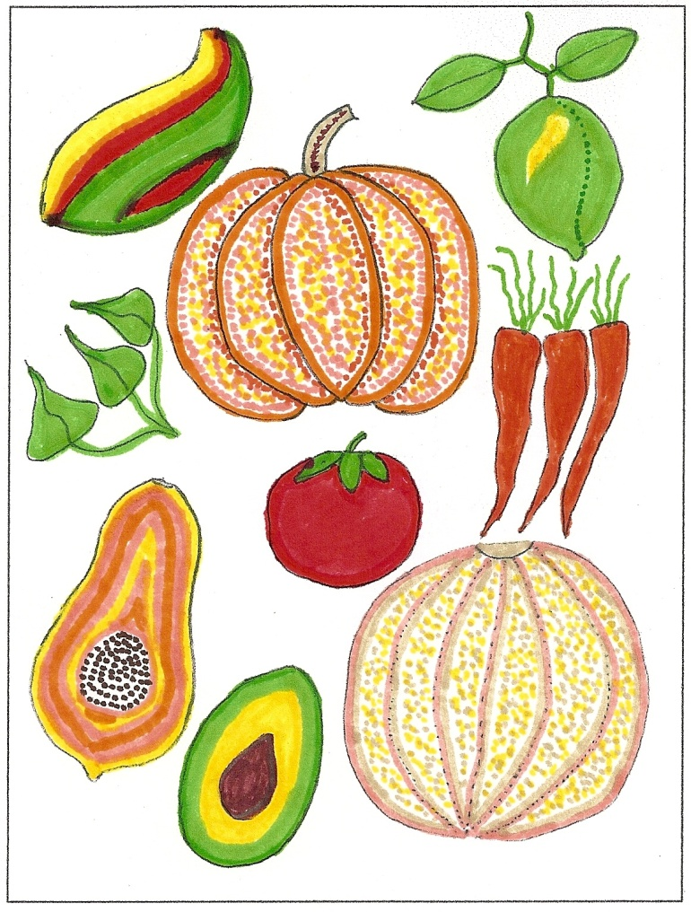
Activity 2. Planning & clearing a small area of the plot and looking at a sample of fencing.  Purpose  Show how the best spot was chosen for a bed in this demo garden, and discuss what to clear off the land; discuss fencing options.  - Discuss the location of the beds in relation to space, exposure, sun. What decisions were made.  - Show what was cleared off of the garden plot and re-emphasize why.  - Show a sample of the fencing that was used.  Planning. A garden must first be planned and designed. In the first year we won’t get into too much detail; let us not scare people away from the idea with too much information. During the course of the year we can gradually teach them more so that they can do a better job of planning for year two.  But first, work with the family to make a decision: a single small bed the first year—or something bigger? Look at the How-To card to get some ideas. Look for an area which is sunny and not too steep. Stake out an area for a bed that is no wider than 1 meter; clear it of any vegetation or trash. Put together a simple fence to protect the bed from animals. Be creative and use any free materials just to get going the first year. The fence could be made of branches, old tires, old barrels, or old pallets.  Use practical examples of the why we need to plan our garden:  We need to plan on sun, exposure to wind or runoff, family size and food production, and crop choice for nutrition.  Use large sheets of paper to design an example garden. Ask participants to sketch their yard and begin thinking of a good location for their garden.  Use practical examples of why we clean and fence the plot:  Residual contamination, weeds, insects, damage from animals. | 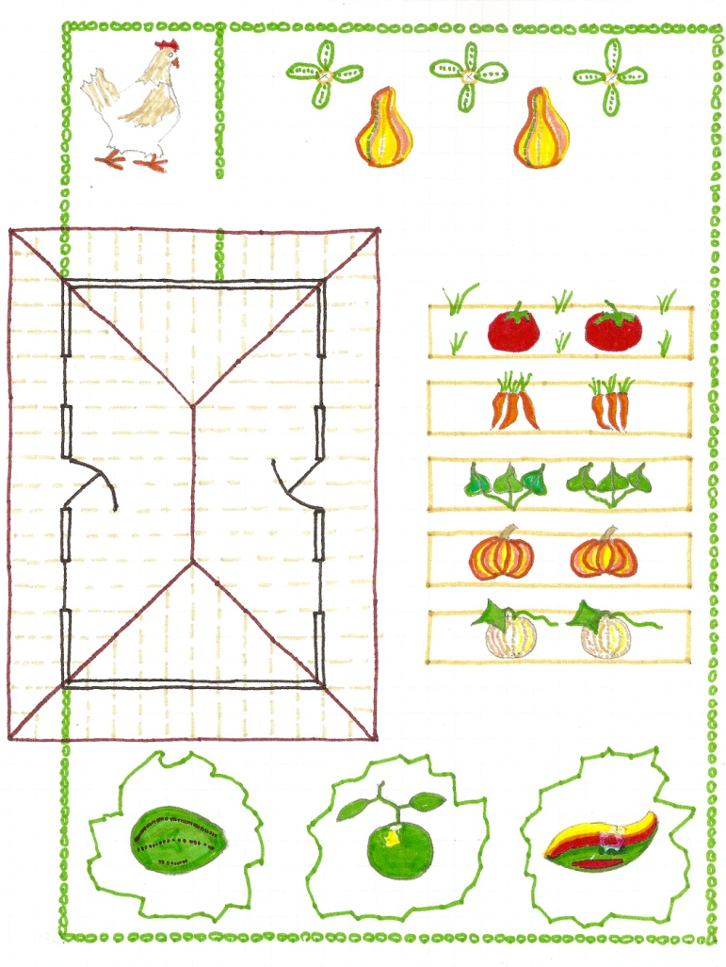
Activity 3. Looking at the organic material samples collected from around the village  Purpose  Explain how many freely available types of OM are available around the village for getting garden plot started.  We will discuss the importance of organic matter in the soil and well-dug beds, and provide and plant seed for nutritious, vitamin A rich, local vegetables.  Discuss the different materials and where they were found.  Have participants discuss other materials that they might be able to use.  Use practical examples of why we loosen the soil and mix in organic material:  Root penetration, drainage, aeration, nutrient availability, structure, micro ecosystem.  Raised Beds. Begin using raised beds. They provide a soft environment for roots, they drain well, and the soil flora and fauna receive the oxygen they need. Soil is a living, breathing organism of sand, clay, organic matter, earthworms, nutrients, minerals, water and plant roots. It can suffer from being too wet, too dry and too sandy. This workshop will detail the importance soil handling and of introducing compost and manure to mitigate these problems.  In the first year, since you may not have compost, begin by spreading whatever chopped-up organic material (OM) you can find on top of the staked out soil. This can be leaves, manure, corn stalks, vegetable-based kitchen scraps. Organic material in garden soil provides nutrients, structure and facilitates holding water. | 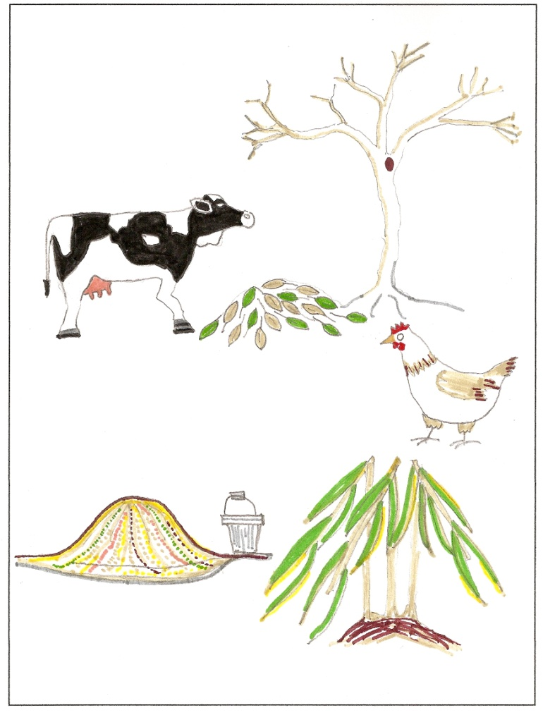
Activity 4. Taking turns laying out and digging a bed, mixing in organic material and smoothing the bed.  Purpose  To practice the digging technique and the shaping of a raised bed.  - Show how to measure and stake out a bed – then let participants lay out two beds.  - Show how to double dig the bed and add in the OM – then let the participants take turns digging the bed.  - Show how the final shape of the bed can be formed and smoothed with a rake.  Beginning at one end of the new bed, dig a 1 meter long trench one shovel in depth and one shovel width wide. Place the soil to the side. See the How-To card for a drawing. With a garden fork or with the shovel, loosen the soil in the bottom of the trench a further shovel depth—but don’t remove it. Place some more organic material in the trench.  Dig a second trench alongside the first one, tossing the soil into the first trench. With the addition of the OM and the fluffing of the soil, the soil should now be higher than the surrounding terrain. Continue this process for the entire length of the bed. Place the soil from the first trench into the last trench.  Using a garden rake, and without walking on the new bed, carefully break up any clumps of soil and rake the surface of the new bed smooth, flat and level. Carefully rake the outer edges so that they are at a 45-degree angle, and so that a small lip forms at the upper edge for holding water. (See the How-To card). | 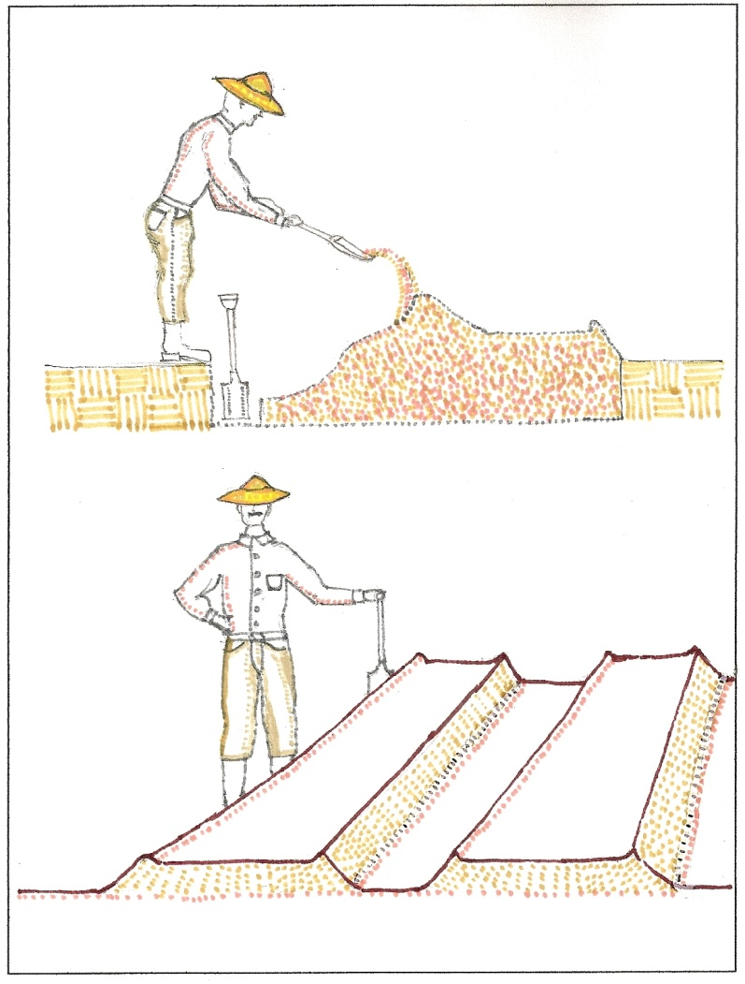
Activity 5. Laying out a seed grid and planting a few example seeds at the right distances and depths.  Purpose  Re-emphasize seed spacing and planting depth.  Use practical examples of seed spacing and planting depth:  Crowding of plants, wasted space, seed size and shoot size vs. depth.  Seed Planting. In the Family Nutrition and Gardens workshop, with the help of the agriculturist, a list of appropriate, nutritious plants should have already been selected and seeds obtained. The seeds should come with directions for correct spacing for planting and correct planting depths.  Working with your community members, explain how to measure out and mark the beds for planting the seeds. Being sure not to walk on the new beds, help them plant the seeds and cover them with soil.  Let the participants finish laying out the beds for the different seed.  Show how the same chart gives seed planting depth; demonstrate making a row or a hole, planting and then covering the seed.  Show how to label the seed rows.  In year one, we planted seeds directly into the garden bed. In preparation for an expanded year 2 garden, we will plant some seed in containers and transfer them to the garden bed after 3 months. This allows us to expand the variety and health of fruits & vegetables.  Activity 6. Planting the rest of the seeds and labeling the rows.  Purpose  To let participants work through the whole process themselves – and to reinforce what has been learned.  Let participants finish planting the seeds in the beds.  Let them label the seed rows. | 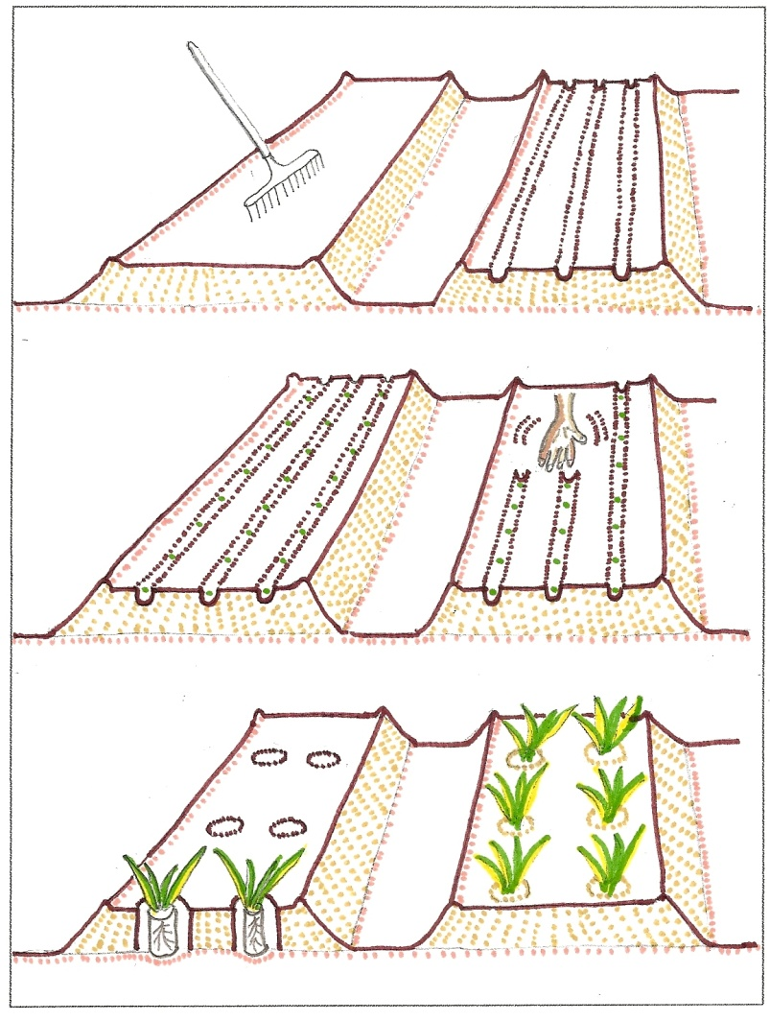
Activity 7. Gently watering the newly planted seedbeds.  Purpose  To let participants work through the whole process themselves – and to reinforce what has been learned.  Watering. If possible, using a watering can with a fine spray, gently water the newly planted seeds. Water slowly enough that the water can soak in and not form pools; pools can cause the seeds to float to the surface.  Simple explanation of watering:  Best times of day, frequency, duration and quantity.  Show the proper technique for watering the new seedbed.  Let the workshop participants take turns watering the newly planted seedbeds.  Future Workshops:  Kitchen Gardens 2.4: Lessons Learned & Planning for Year Two. After first season successes it may be time to expand your garden in preparation for year two. This involves space planning and the election of new plants to try. Did you track successes, challenges, yield and family favorites in the first season?  Kitchen Gardens 1.3: Care & Maintenance. This workshop will address proper watering, weeding - and fertilizing with locally available manures. We will also discuss garden architecture such as fencing, stakes and plant supports. An introduction to pest management will be covered. | 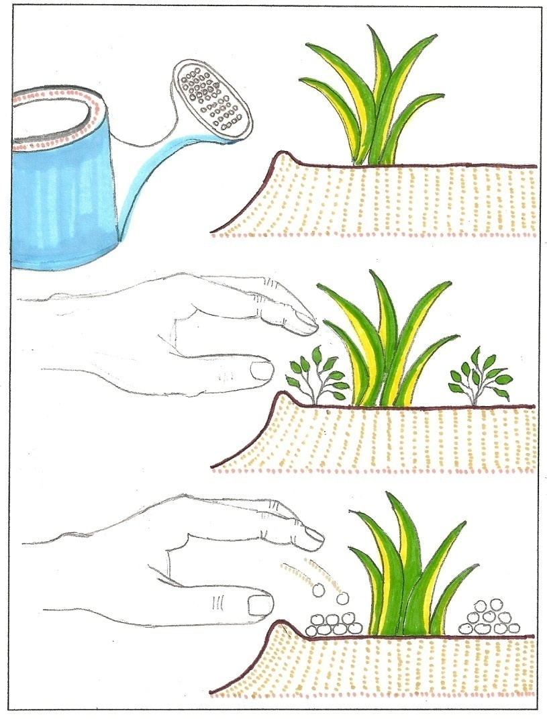
Composting  Organic matter in garden soil provides nutrients, structure and holds water. Vegetable matter such as leaves, kitchen waste and manure can be placed in a pile for 3-6 months for partial decomposition. This workshop gives us a jump-start on year 2 Kitchen Gardening.  Soil  Soil is a living, breathing organism of sand, clay, organic matter, earthworms, nutrients, minerals, water and plant roots. It can suffer from being to acid, too wet, too dry and too sandy. This workshop will detail the importance soil handling and of introducing compost and manure.  Additional Tools:  A Lesson Plan is available for field staff to use to use this information in leading this workshop, and in following up with the families.  Nutrition and Kitchen Garden How-To Card. How-To cards are a two sided sheet that can be downloaded, photocopied and given to workshop participants to take home. They are illustrated, don't have words, and serve as reminders of what was learned in the workshops. | 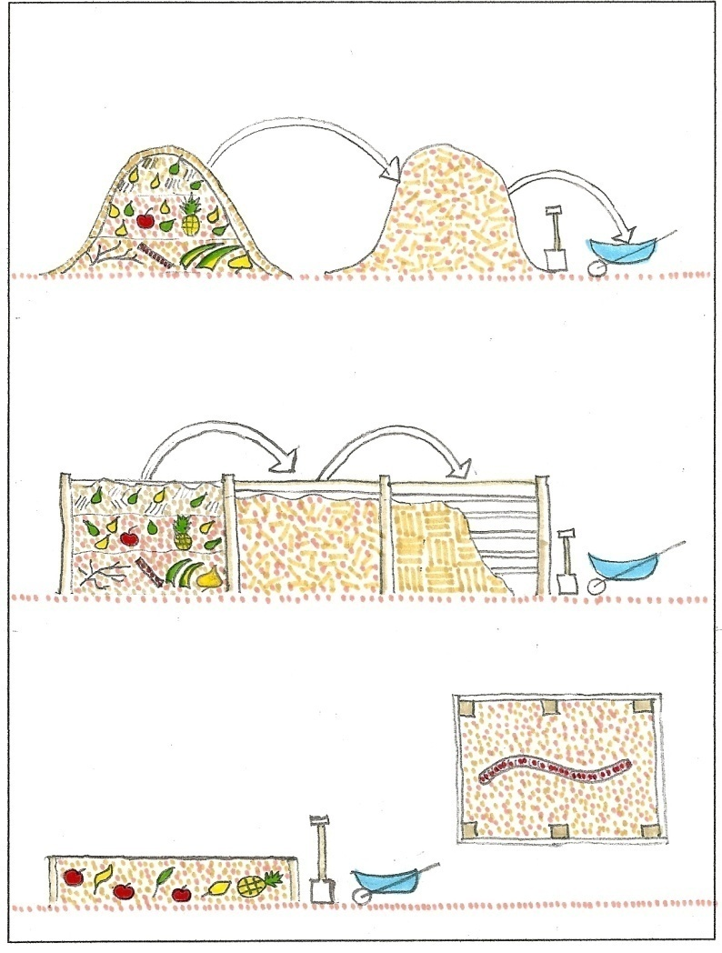
 | 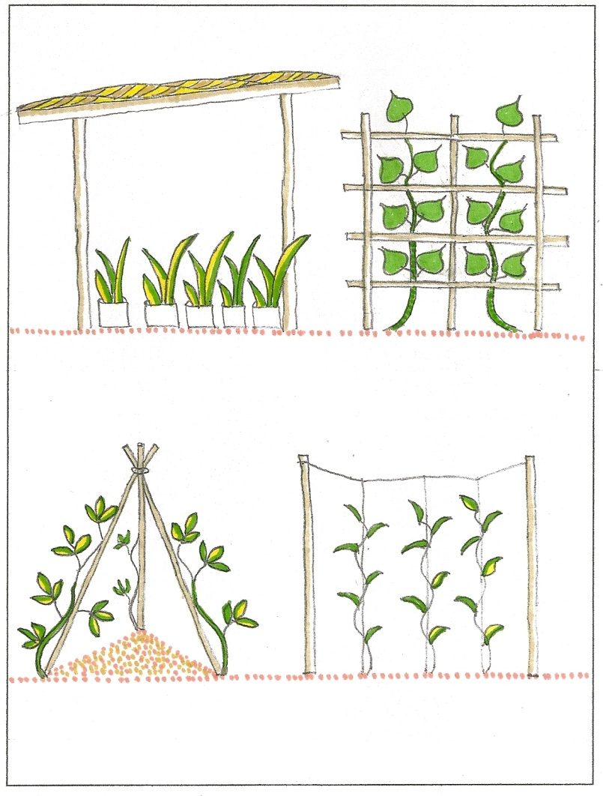
https://www.csd-i.org/ © Center for Sustainable Development

