HOW TO CONSTRUCT SUBSURFACE DAMS OF SOIL

C Copyright Erik Nissen-Petersen. asalconsultants@yahoo.com

INTRODUCTION

Subsurface dams built of soil in dry riverbeds (sand rivers) are the most reliable and low-cost water source in Arid and Semi-arid Lands (ASAL). Many subsurface dams have been constructed successfully of soil near Dodoma in Tanzania since 1912. More recently, training on subsurface dams built of soil took place in Dodoma, Makueni and Turkana in Kenya and in the Dry Zone of Burma by the author.

Subsurface dams prevent floodwater, which has saturated the voids between the sand particles in riverbeds, from being drained downstream by gravity thereby drying up riverbeds.

Subsurface dams should, preferably, be constructed on underground dykes situated under the sand, because that will provide free storage volume for water.

Subsurface dams can be constructed in riverbeds having no underground dykes, although such water reservoirs are likely to have smaller storage volumes.

Water is extracted from subsurface dams by either a hand-dug well with a hydro-dynamic well-head sunk in the riverbed itself, or by an intake pipe gravitating water to a well-shaft sunk in a riverbank.

Subsurface dams let floodwater pass without reducing the flow to people living downstream. These subsurface dams do not require maintenance. They cannot be eroded or silted up and hardly any water is lost to evaporation.

Subsurface dams are so easy to build of soil that farmers can construct such dams themselves after a short training course.

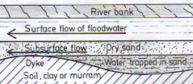Fig. 1. Floodwater trapped in the sand upstream of an underground dyke.

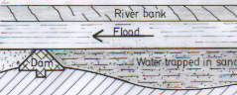Fig. 2. A subsurface dam constructed on an underground dyke increases the volume of water trapped in the sand.

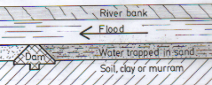Fig. 3. A subsurface dam can also trap floodwater in riverbeds having no underground dykes.

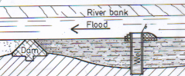
Fig. 4. A hand-dug well with a hydro-dynamic well-head in a riverbed for extracting water from a subsurface dam.

SlTE CRITERIA

1) Coarse sand can store more water in its voids than fine-grained sand. The
highest yield of water can therefore be drawn from riverbeds with coarse sand.

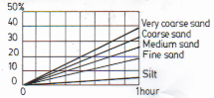Fig. 5. Percentage of extractable water.

- Subsurface dams should not be
located where waste from slaughter houses, villages and cattle dips, contaminates the riverbeds.

- The reservoir of subsurface dams
should not contain salty soil or rocks because that will make the water salty.

- Boulders and fractured rocks
should not be situated in the reservoirs because they cause leakage.

- Underground dykes are best located
a couple of months after flooding by:

- There is always an underground
dyke downstream of a waterhole because dykes trap water upstream.

- Dry and low vegetation on a
riverbank with tall green trees.

- The presence of a dyke is confirmed
by either digging trial pits, or/and …

- … probing with an iron rod hammered into the sand, or/and …

- … dowsing with two rods made from a brazing rod.

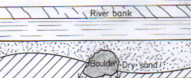
Fig. 6. A boulder creating leakage.
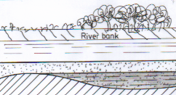
Fig. 7. Dry vegetation indicates an underground dyke, while tall green trees show where water can be drawn.

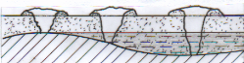Fig. 8. Waterholes provide water due to an underground dyke being downstream.
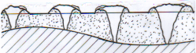
Fig. 9. Trial pits can be dug in riverbeds to confirm dyke and extraction point.
Fig. 10. Probing rods made of iron bars can also show dyke and extraction point.
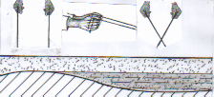
Fig. 11. Dowing rods can be used by gifted persons.

DESIGN CRITERIA

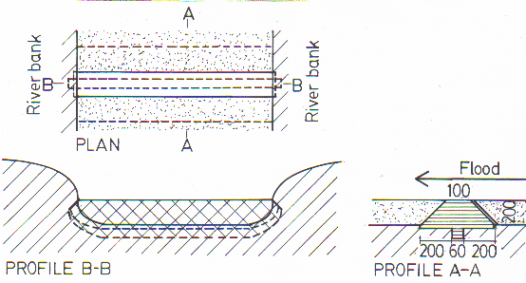Fig. 12. Standard design of a subsurface dam built of soil.

- 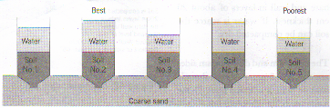Subsurface dams must keyed into the
floor under the full length of the dam wall and into the banks to prevent seepage. The key is made by excavating a trench 60 cm wide and 60 cm deep into firm soil or murram under the dam wall. The trench is filled up with moisten layers of the least porous soil found at the dam site.

The porosity of soil can be found by observing, say 10 cm depth of water seeping through 20 cm depth of various soil samples taken at a dam site. The soil samples are filled into transparent plastic bottles turned upside down with their caps and bottoms removed. The soil samples are saturated with water, then topped up with water. The sample with the slowest infiltration rate is the most suitable soil for building a dam wall because it has the least porosity.

Fig. 13. Soil samples being analysed.

- The minimum width of the crest
(top) of a dam wall is 100 cm. However, if it takes less than 60 minutes for 10 cm depth of water to seep through 20 cm depth of soil, then the crest should be made 5 cm wider for every one minute less the 60 minutes.

- The sides of a dam wall should
slope 45 degrees outward from the crest.

- The upstream side of a dam wall
should be coated with a 5 cm thick layer of clay or cow dung for water-proofing.

CONSTRUCTION
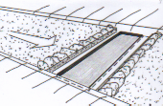
- The sand overlaying an underground
dyke is removed in a stretch being 2 metres wider than the base of the dam.

- The width of the base is excavated to
a depth of 20 cm into the clay or murram being the floor of the riverbed.

- A key, 60 cm wide and 60 cm deep
or more, is excavated into firm soil along the middle of the dam wall and to the top of both ends of the dam wall.
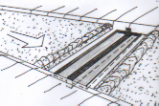
- The dam wall is build of the least
porous soil found on the site. The soil is moisten and compacted into the key and dam wall in layers of about 20 cm thickness until the top of the dam wall.

- The sides of the dam wall are cut to
45 degrees slope and smoothen.

- The upstream side of the dam wall is
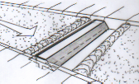water-proofed by compacting a 5 cm layer of clay or cow-dung mixed with soil onto the dam wall.

- Upon completion of the dam wall,
sand is back-filled against both sides so that the top of the wall is equal with the level of sand in the riverbed.

8) When the riverbed has been flooded and the subsurface dam has proved to hold water, a hand-dug well can be sunk into the riverbed or one of the banks.

MAINTENANCE
There is no maintenance required for a subsurface dam built of soil.

Only the hand-dug well, or a river-intake being the extraction point might need attention after floods

.
Fig. 14. Sand has been removed in a wide stretch over a dyke. The base of the dam wall has been excavated to a depth of 20 cm into firm soil.
Fig. 15. A key, 60 cm wide, has been excavated 60 cm into firm soil under the middle of a dam wall. The key extends into the two river banks.
Fig. 16. The key and dam wall have been built up the level of sand in layers of compacted soil with the least porosity.
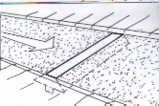
Fig. 17. The dam wall is completed and sand has been back-filled against it.

