OL 332 A7 Field Guide: Household Rooftop Rainwater Harvesting. Tim Magee
Introduction. Access to household water has become increasingly challenging in many parts of the world. Frequently women and children must walk several kilometers to collect water—taking time away from livelihood tasks and from school. Rainwater harvesting systems can be easy to build, inexpensive, and provide a meaningful quantity of water. They consist of a roof, a gutter, a downspout and a tank. Organize a workshop for 12 to 15 community members on rainwater harvesting.

Notes. Determine two things prior to offering the workshop. One: that rooftop rainwater harvesting is a viable option for your locale based upon types of roofing, annual rainfall, length of the dry season, and family water consumption. Two: determine local costs for installations and local material options for use in construction, and investigate water storage system designs that are appropriate for your community context. You should contact a local expert for assistance in designing the systems and in designing the workshop.

The catchment surface: The roof of your home. The size of a roof determines how much water can potentially be collected in a year. For example, a 24 m² roof in an area with an annual average of 400 mm of annual rainfall can collect and store a three month supply of water for a family of six. Most roof systems work well for capturing rainwater: the best are concrete, tile or corrugated sheet metal. Thatched roofs can be dirty and difficult to attach a gutter to. However, water collected from thatched roofs can be used in home vegetable gardens. Even “flat” concrete roofs have a slope and a low point where you can collect water.

Gutters and downspouts. At the low edge of the roof it is necessary to install a gutter to collect rainwater before it falls to the ground. Gutters can be made of V-shaped pieces of sheet metal, strips of corrugated roofing bent into a C-shape, or PVC or bamboo tubes split in half. These gutters need to be suspended from the roof edge such that all of the rainwater flows into the gutter. The gutter needs to slope downhill from one end to the other end in the direction of your storage tank. Watch during the first few rainstorms to see if your gutter is working effectively. Downspout: Connect one end of a piece of tubing to the end of the gutter and the other end to an opening in your tank.

The storage tank. The tank is the most expensive portion of the system. Because of this, and to simply get started, you can begin collecting rainwater in found containers such as jerry cans or barrels.

The optimal size of the tank will vary based on how large your roof is, what the annual rainfall is, how long the dry season is, how large your family is, and how much of the captured water is to be stored for future use. Three months of water (a large tank) for a family of six represents half the water they need during a six-month dry season. During unpredictable rainy seasons, a rainwater harvesting system can provide supplemental water during short dry periods with smaller storage containers. Tanks can be aboveground tanks made of concrete blocks, reinforced concrete, or pre-purchased plastic tanks. In-ground cisterns can be as simple as an earth reservoir lined with sheet plastic—or a brick lined excavated hole.

Planning. Help each participant determine the amount of potential water they can harvest during the course of a year and how much water they need for their family during the dry period. Realizing that costs for building a tank can range from $50 for a plastic lined excavated hole up to $500 for an aboveground tank of concrete block, work with the participants to determined what their best plan would be for their home and resources. Discuss how you decided which materials to use for the gutter, for the tank—and for the size of the tank for the demonstration installation.

Construction. Deliver the construction materials to the site in advance. Check that you have the correct tools that you need and that you have extras so that several people can participate at the same time. In order to build a system with the time allowed in a workshop, the tank should already have been installed. You should have examples of several types of gutters, downspouts, containers and plastic sheeting used for lining an excavated hole.

Begin by showing the correct placement of the gutter so that it will effectively catch the water as it flows off of the roof—and how the gutter needs to slope downhill from one end to the other towards the tank. Let the participants install the gutter and the downspout that leads to the tank. Place a piece of wire mesh where the gutter meets the downspout to catch leaves and debris. Run a trial by pouring a bucket of water on the roof to see that the gutter catches the water and that the water flows easily to the tank without leaks.

First Flush. The first rainfall of the season will clean the roof and can potentially flush dirt into the tank. Disconnect the downspout from the tank during the dry season until the first rain can completely clean the roof and the gutters. If the tank is empty—it should also be cleaned out at this time. After the first rain, reconnect the downspout to the tank.

Water Purification. Rainwater collected from rooftops may have impurities and it such as windblown dust or bird droppings. Secondly, storage conditions may not be optimal. Rodents may get into the storage tank. Water stored for several months may become mildly contaminated. The water needs to be purified or filtered. This could be with point of use water filters, with the addition of chlorine, or by using a solar disinfection system.

Maintenance. Roof surfaces need to be kept free from dirt; gutters, drain pipes and wire mesh cleared of leaves & dirt.

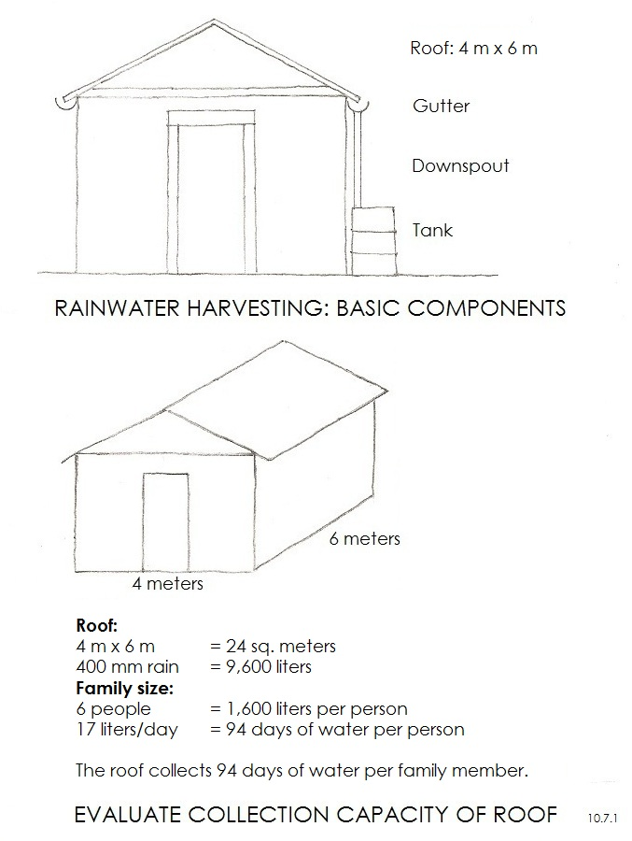 | 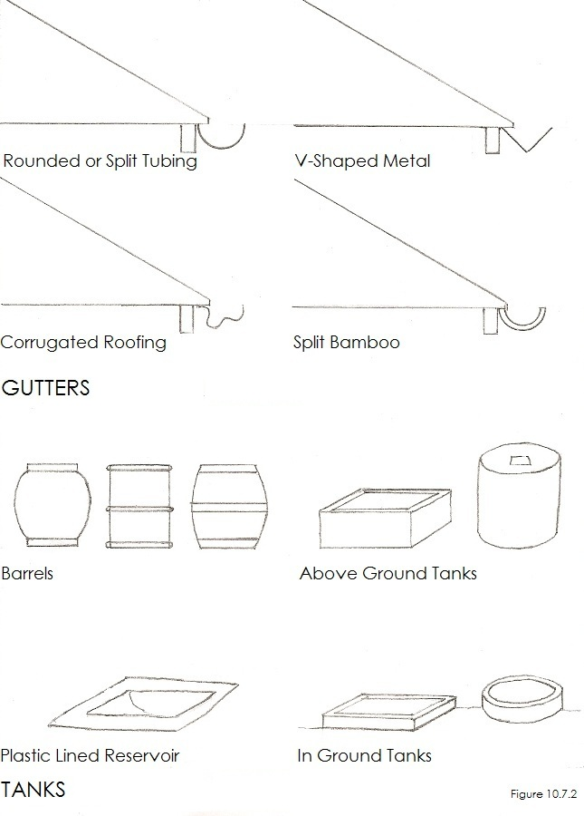
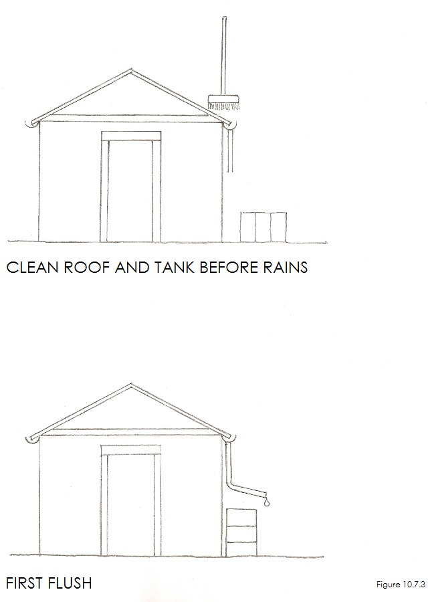 | 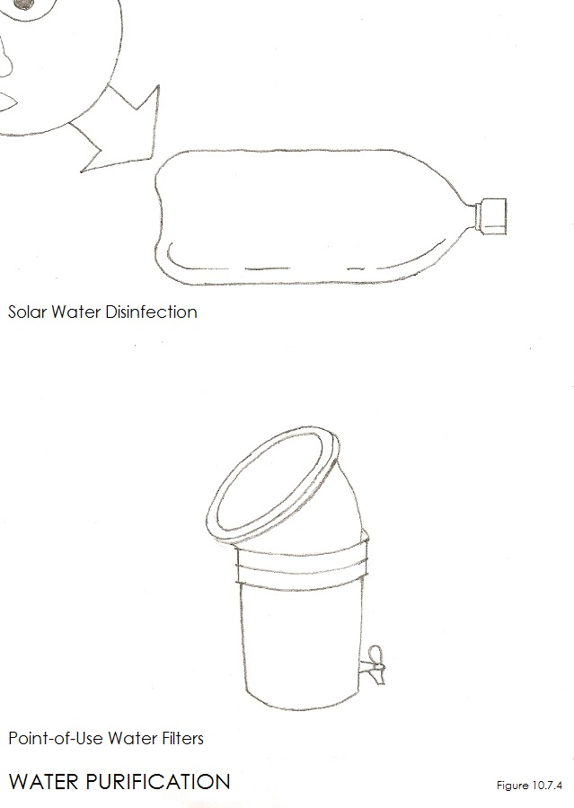

OL 332 A7: Workshop Lesson Plan for Household Rooftop Rainwater Harvesting.
5 ½ hours (can be completed in one 2½ hour workshop and one 3 hour workshop)
PURPOSE: What workshop participants will be able to do as a result of the lesson.
Objective 1: Participants will understand the benefits of rainwater harvesting.
Objective 2: All will understand the basic design components and appropriate materials for use in construction.
Objective 3: Participants will know how much water they can collect in a year and how much their family needs.
Objective 4: Participants will know how to assemble and maintain a rooftop rainwater harvesting system.
MATERIALS
- Artist’s drawings/posters; the scenes and people they contain should appear familiar to workshop participants.
- How-To Cards without written words for workshop participants to take home.
- Large sheets of newsprint and tape. Colored markers.
- Example materials to be used for gutters, downspouts, containers and storage tanks.
- Tools for installing the gutter, downspouts and, if appropriate the storage tank.
PREPARATION
- Determine that rainwater harvesting is viable in your location. Determine costs and appropriate local materials.
- Find a home that belongs to a member of the community willing to host a demonstration installation.
- Materials for installation should be on site prior to the workshop. The tank should have been installed.

BEGINNING OF LESSON:
Activity 1. 40 minutes (including a 15 minute ice-breaker). Introduction to the benefits of rooftop rainwater harvesting
Purpose: Participants will understand the benefits of rainwater harvesting.

What to do
- Ice Breaker: Introductions. Sing a song or play a game.
- Introduction to workshop: Tell the participants what they’ll be able to do as a result of the lesson.
- Participants will learn that a rainwater harvesting system can provide a meaningful quantity of water for their families.
- They will learn a system consists of a roof, a gutter, a downspout and a tank.
- All will learn much of the system can be inexpensive, and that expensive components (tank) can be phased over time.
Workshop Participants:
Take 5 minutes to talk about what you do and don’t understand, what you do and don’t like.

Activity 2. 15 minutes. The catchment surface: the roof of your home
Purpose: To understand how the roof functions in the system.

What to do
- Discuss how a roof catches rainwater that flows to the low edge of the roof and can be collected in a gutter.
- Discuss that concrete, tile, or corrugated sheet metal performed best.
- Thatch roofs can be dirty, can be difficult to attach gutters to, but can collect rainwater for vegetable gardens.
- Prior to the rainy season the roof should be cleaned and should be kept free of leaves during the rainy season.
Workshop Participants:
Have participants talk about what they do and don’t understand, what they do and don’t like.

Activity 3. 15 minutes. The gutter and downspout
Purpose: To understand how the gutter and downspout function in the system and how they are installed.

What to do
- Show samples of what a gutter looks like and samples of the different materials that can be made from.
- Show the position that the gutter should be placed in so that it can catch all of the rainwater flowing off of the roof.
- Show how the gutter needs to slope downhill from one end to the other towards the tank.
- Show how the downspout tubing connects to the end of the gutter to direct the water into the tank.
Workshop Participants:
Have participants talk about what they do and don’t understand, what they do and don’t like.

Activity 4. 20 minutes. The tank
Purpose: To understand what alternative designs there are for tanks and what materials can be used.

What to do
- Discuss the fact that tanks can be an investment. Other containers like barrels can be used temporarily.
- Describe how a small reservoir can be dug in the ground and lined with plastic to store water.
- Describe different styles of above ground tanks and the materials that they can be made from.
- Describe different styles of below ground tanks and different materials that they can be made from.
- Discuss the different materials costs and discuss the different benefits that each tank style offers.
- The size for a tank will depend on the size of the roof, annual rainfall, length of the dry season, and the size of the family.

BREAK: 15 MINUTES
Activity 5. 20 minutes. Planning
Purpose: For each person to experiment with the best design options and the best investment level for their family.

What to Do:
- Each participant will determine how much water they can capture, and how much their family needs per year.
- Since tank costs vary substantially, help the participants determine which option is best for them.
- Discuss how you decided on the materials to use for the gutter, tank—and for the size of tank for the demonstration.
Workshop Participants:
Have participants talk about what they do and don’t understand, what they do and don’t like.

If you're planning on doing this workshop in two sessions—this would be a good place to stop.
If you're planning on doing this workshop in one session—this would be a good place for a break and a snack.

Activity 6. 2 hours. Construction
Purpose: To learn the steps involved in installing a rainwater harvesting system.

What to do
1. Reinforce the correct placement and downhill slope of the gutter and let the participants install the gutter.
2. Show how to connect the downspout/tubing which leads to the opening in the tank—and let the participants install it.
3. Place a piece of wire mesh over the opening where the gutter meets the downspout to catch leaves and debris.
4. Test installation by pouring a bucket of water on the roof. See that the gutter catches the water and there are no leaks.

Activity 7. 20 minutes. First flush, use, and water purification
Purpose: To learn the steps in maintaining a clean system and purifying the water before using it.

What to do
1. The first rainfall will clean the roof and can flush dirt into the tank.
2. Disconnect the downspout from the tank during the dry season until after the first rain cleans the roof and the gutters.
3. Clean the tank out (directions below) at the end of the dry season and before the beginning of the rains.
4. Underground tanks may require a hand pump or bucket to retrieve water. Above ground tanks can use spigots.
5. Rainwater collected from rooftops may have impurities and it such as windblown dust or bird droppings.
6. Drinking water needs to be purified or filtered with point of use water filters, chlorine, or by using a SODIS.

Activity 8. 20 minutes. Maintenance
Purpose: To learn the steps involved in maintaining and repairing a rainwater harvesting system.

What to do
1. Regular maintenance (dry season)
- Roof surfaces have to be kept free from bird droppings & other dirt
- Gutters, drain pipes & inflow filters must be regularly cleared of leaves & dirt
- Disconnect downspout from entrance into tank at end of dry season until after the first rain for cleansing flush

2. Annual maintenance (at the end of the dry season)
- At the end of the dry season, when the tank is empty, repair leaks
- Repair roof, gutters, inflow pipes, filters
- Remove deposits from bottom of tank
- Mix 1 cup of Chlorine bleach (5%) with 45 liters of water, pour into tank, scrub clean with chlorine solution, leave tank with solution in it for 24 hours. Flush tank out with clean water—then connect downspout to clean tank.

Activity 9. 30 minutes. Conclusion
Purpose: To review rainwater harvesting system and provide feedback.
What to do
1. Reinforce the benefits of rainwater harvesting.
2. Review the basic design components and appropriate materials to use for construction.
3. Review how much water can be collected at a participants’ home and how much water is needed by the family.
4. Review the planning process of designing the system and the costs of installing a system.
5. Review the first flush, use of the system, and maintenance of the system.
Workshop Participant Feed Back:
Take 10 minutes to talk about what you do and don’t understand, what you do and don’t like.

Follow-up. Your organization should set up a follow-up schedule with each of the workshop participants to assist them in the installation of their harvesting systems.
Copyright © Tim Magee

