OL 332 Assignment One PCVA How to Card
Online Learning: OL 332 Water Conservation & Management
Center for Sustainable Development. https://csd-i.org/ol-332-water-conservation-management/

How to Card: Participatory Capacity and Vulnerability Assessment
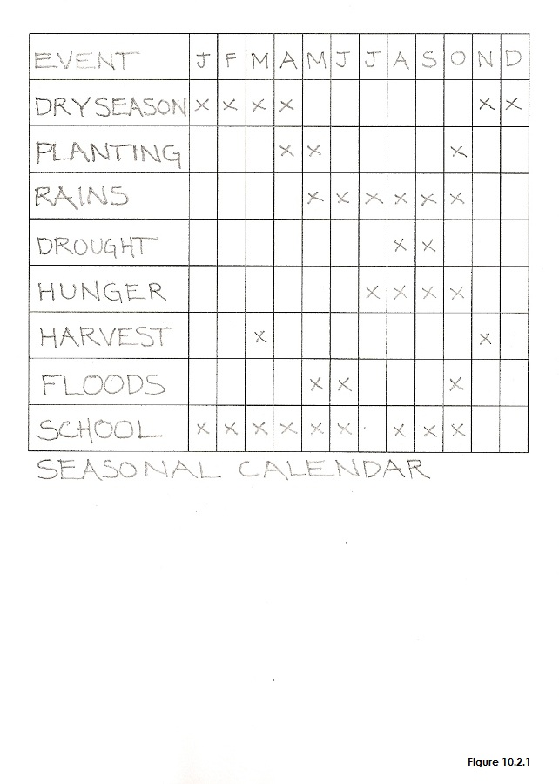 | 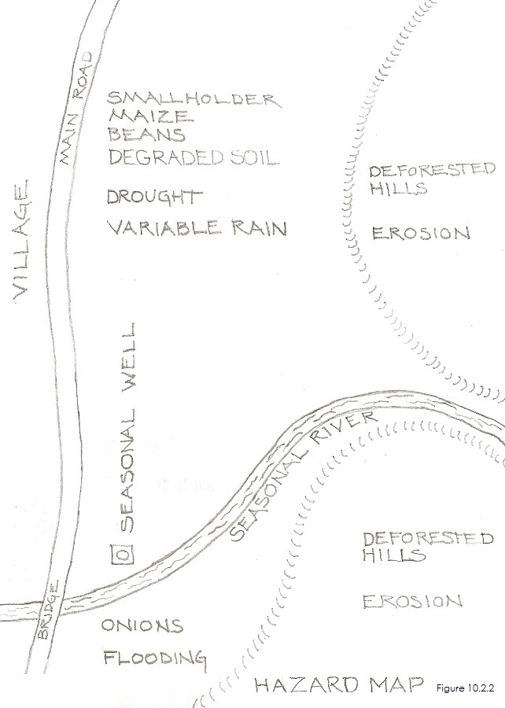
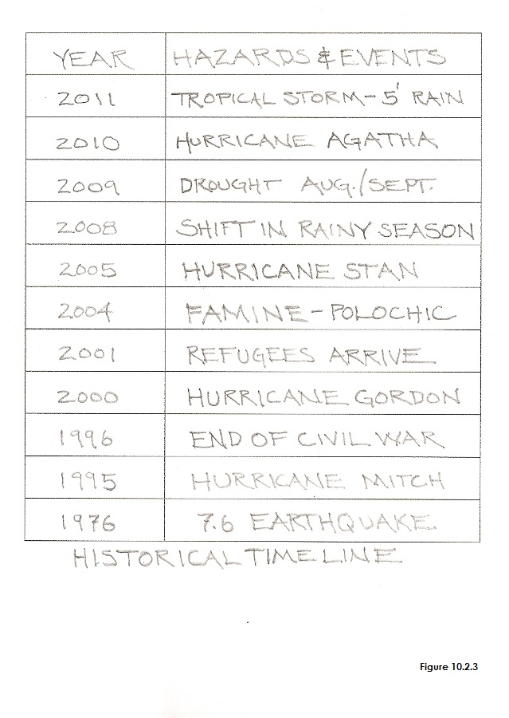 | 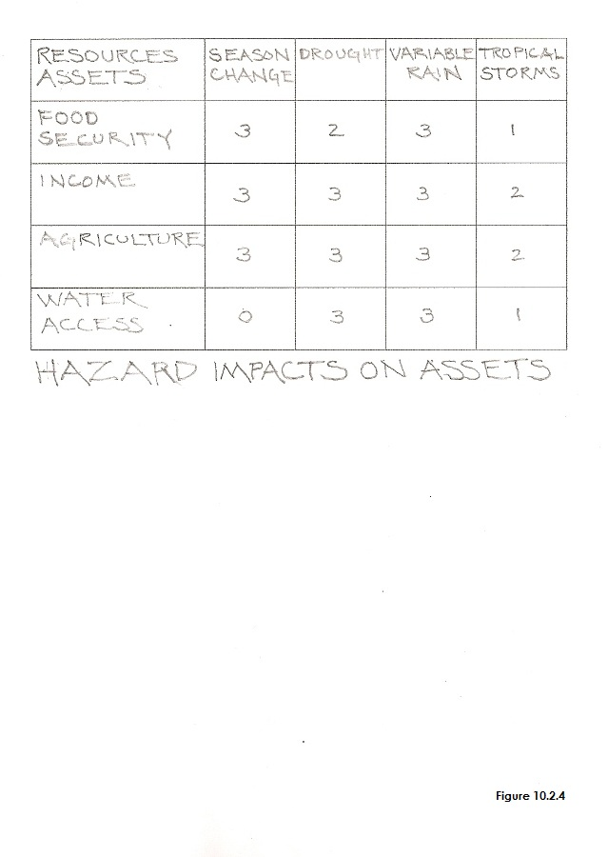
Copyright © Tim Magee

