OL 333 Assignment One PCVA How to Card
Online Learning: OL 333 Climate Smart Agriculture.
How to Card: Participatory Capacity and Vulnerability Assessment
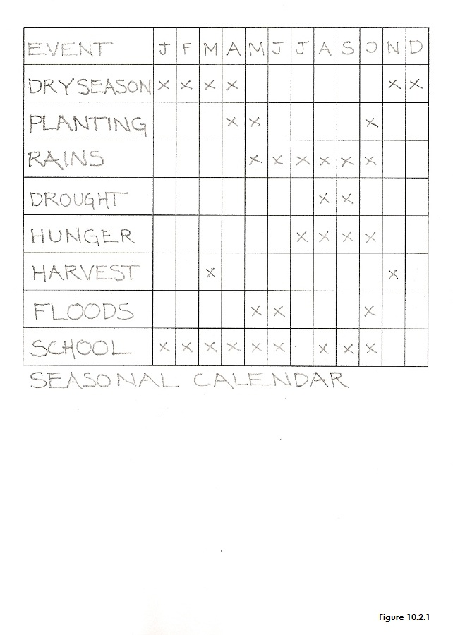 | 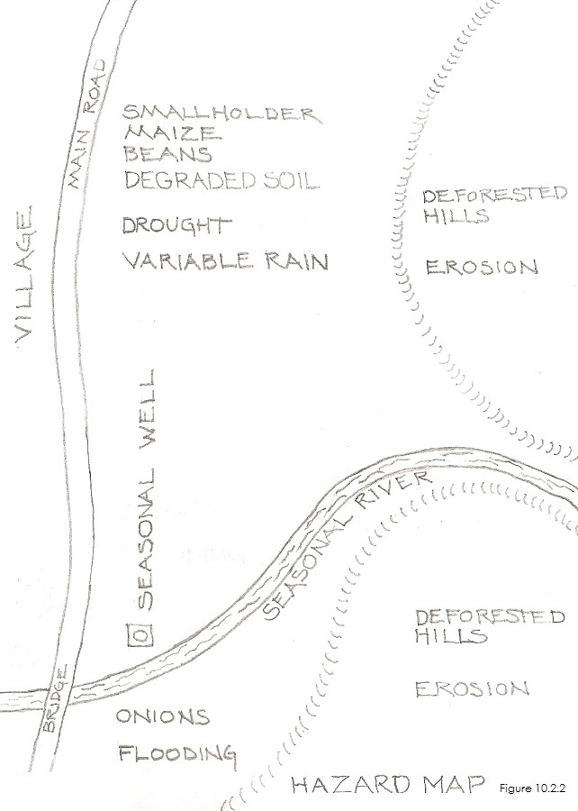
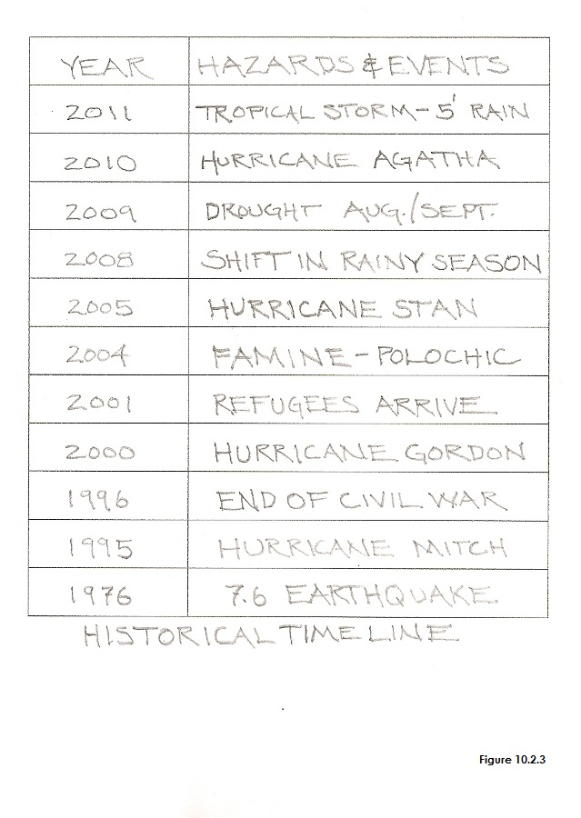 | 