OL 333 Assignment One How to Card
Online Learning: OL 333 Climate Smart Agriculture.
How to Card: Participatory Mapping of Soil and Water Resources
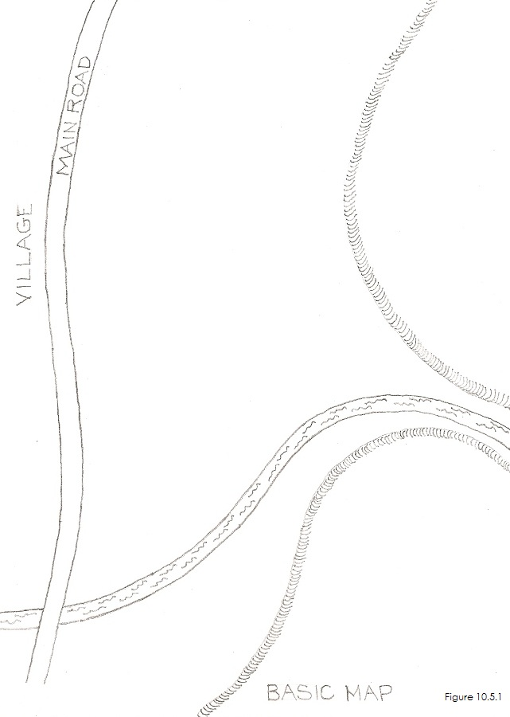 | 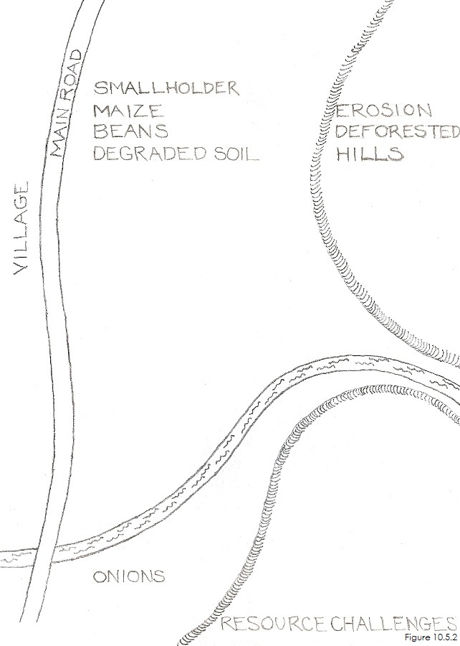
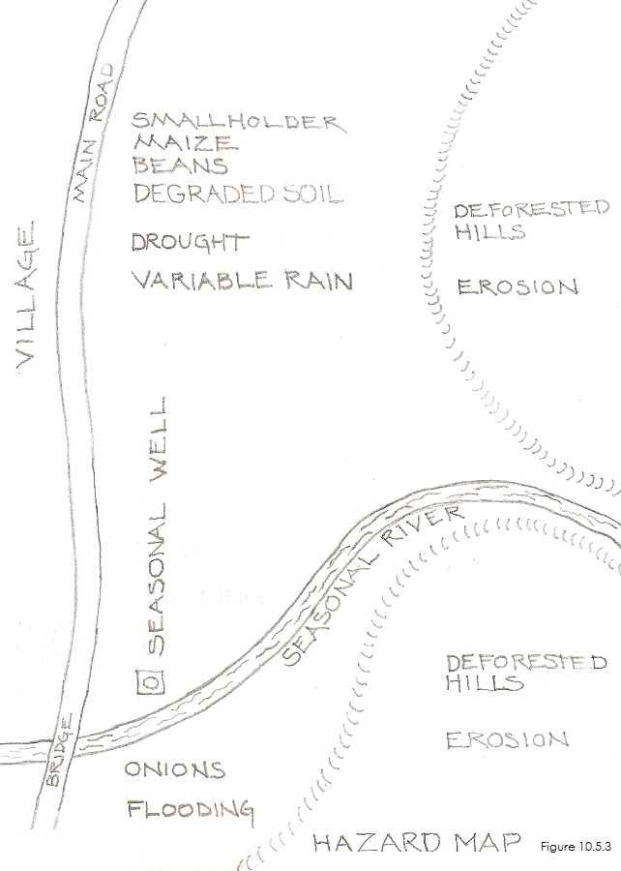 | 