Soil Restoration and Conservation for Smallholder Farmers Field Guide
Tim Magee

Worldwide, challenges for smallholder farmers have increased. Harvest production may be down leading to reduced incomes and reduced crops for family consumption. These challenges can be due to depleted soils, lack of funds for purchasing fertilizer, changes in the beginning and end of the rainy season, unpredictable rain during the rainy season, and increased soil erosion and crop damage during extreme weather events. There are simple, low-cost/no-cost activities that subsistence farmers can adopt that can increase harvest production by restoring soil, reducing the need for chemical fertilizers, buffering the effects of variable rainfall, and protecting valuable topsoil from erosion, thereby increasing family nutrition and agricultural income.

What is soil? Soil is a living, breathing organism of, clay, organic material, earthworms, microorganisms, beneficial flora and fauna, nutrients, minerals, water and plant roots. Plant growth can suffer if soil is too wet, too dry and too sandy, too clayey, too exposed and too steep.

Soil moisture. Moisture in the soil is a chief determinant in crop growth and in agricultural production. Soil moisture improves soil chemical processes and also acts as a transport mechanism for getting nutrients to the plants. Moisture stored in the soil provides a buffer during dry periods or during periods of unpredictable rain. Sufficient organic material in the soil and mulch on the surface of the soil can help rainwater percolate into the soil in order to build up soil moisture.

Organic material. Organic material decomposes in the soil and releases vital nutrients for crops—reducing the need to purchase expensive fertilizer. Increased organic material in the soil also helps to retain soil moisture for longer periods of time—buffering against unpredictable rain or an early end to the rainy season. Organic material in the soil is a benefit for root penetration, drainage, aeration, nutrient availability, soil structure, and can neutralize pH imbalances.

Discussing the Importance of organic material. In the first year, farmers may not have organic material. Let them know that they can begin by spreading whatever chopped-up organic material (OM) they can find on top of their field. This can be leaves, manure, chopped-up corn stalks, vegetable-based kitchen scraps. Explain how many freely available types of OM are available around their village; have participants discuss other materials that they might be able to use. Discuss the importance of re-incorporating maize stalks and other crop residues back into the soil rather than burning them prior to planting.

Incorporating organic material into your soil during soil preparation. Farmers can spread organic material on top of their field as they prepare their fields prior to tilling. The organic material will mix in with their soil during tilling.

Mulching for increased organic material, and reduced erosion and evaporation. The addition of mulch to the top of the soil can reduce soil temperature, keep weeds down, improve drainage, attract earthworms, and reduce both wind and water erosion. It can be an excellent method of adding organic material to the soil as the mulch decomposes during the course of the growing season. It is excellent for water conservation: it reduces evaporation protecting garden plants by retaining soil moisture when water is scarce. Adding mulch to your field is very simple. Use the same materials that you used for making compost: leaves, dry grass, rice stalks, straw, and other agricultural residues. Simply place a thin layer on the soil after planting seeds. As the plants begin to grow add another layer until you have 5 to 10 cm.

Making compost. Compost is the earthy, dark crumbly material that results from the decomposition of plant residue. It is rich in nutrients and organic matter and can be used as a plant fertilizer. To make compost you need the right mix of organisms, air, water and plant wastes such as grass clippings, food scraps, manures, leaf litter and straw.

Compost can be made in a bin or simply as a pile approximately a meter square and meter high. Find a location for the compost pile that is well-drained and sunny. Unless you're lucky enough to have the materials that you need to make an instant compost pile, begin adding materials as you collect them to the top of the pile. It's good to alternate layers of dry things like leaves and straw with layers of green grass clippings and kitchen waste. A compost pile should be turned every two or three weeks to allow more air into the compost pile. Show the participants examples of finished compost so they know what it should look like.

Compost can be added to the field's surface before preparation for planting—in this way it will mix in with the field’s soil during tilling and be accessible to the plant's roots. It can also be added to the surface of the field after planting and before the application of mulch. Its nutrients can then percolate into the soil with rainwater.

Conclusion. Even highly depleted soils can over the course of several years be restored to a vital condition. The addition of organic material and compost will increase the soil's ability to retain moisture, increase nutrients stored in the soil, increase beneficial microbes and soil flora and fauna and will improve the structure of heavily compacted soil. Mulching will conserve restored soil by reducing moisture loss through evaporation, will contribute organic material and nutrients to the soil, and will prevent the loss of valuable topsoil by protecting the soil from wind and water erosion.

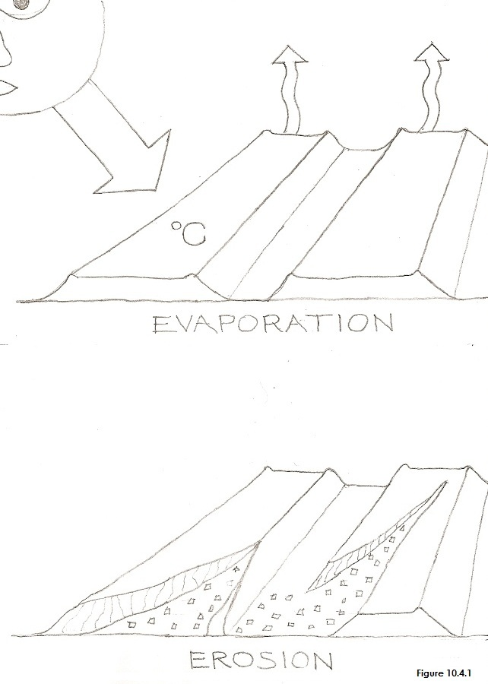 | 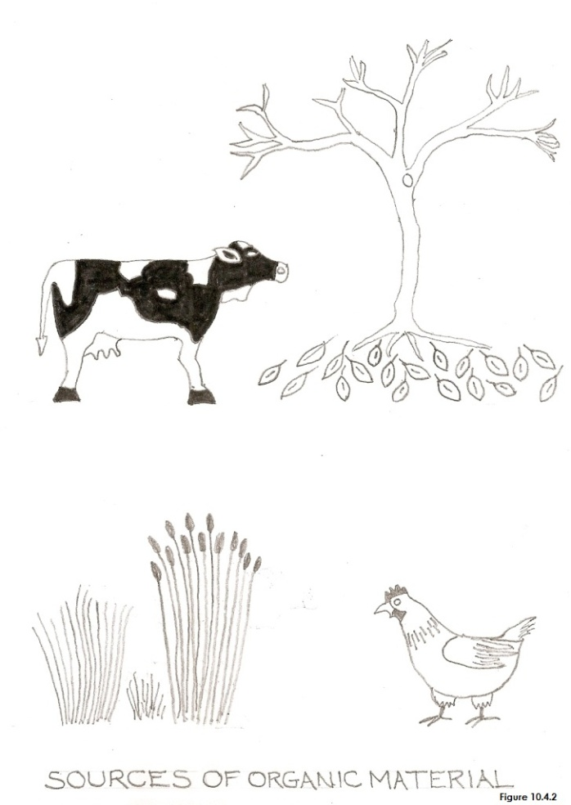
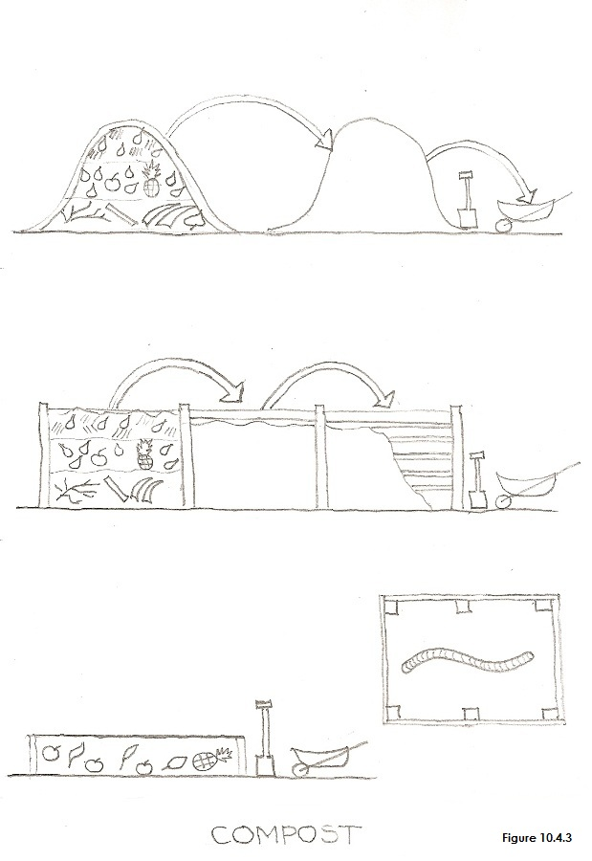 | 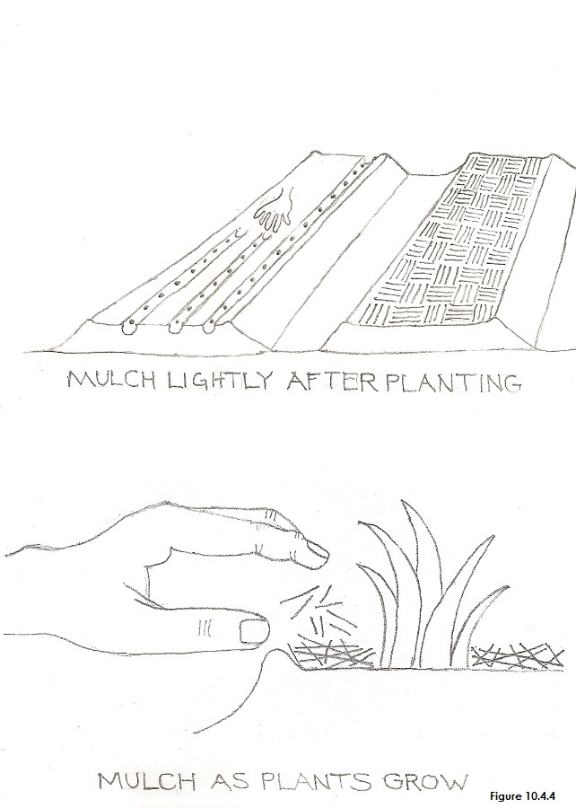
INSERT FIGURES 10.4.1, 10.4.2, 10.4.3, and 10.4.4, NEAR HERE

Field Guide 4: Workshop Lesson Plan for Soil Restoration and Conservation for Smallholder Farmers
8 hours including lunch (can be done in two, ½ day workshops)
PURPOSE: What workshop participants will be able to do as a result of the lesson.
Support participants in learning about the importance of soil restoration and conservation.
Objective 1: All participants will understand what soil is composed of and the importance of moisture in soil.
Objective 2: All will know the importance of organic matter (OM) in soil and that that OM helps soil retain moisture.
Objective 3: All will understand that mulch can protect and conserve soil, and reduce evaporative losses.
Objective 4: Participants will understand how to build a compost pile.
Objective 5: All will understand how to apply mulches and incorporate organic material and compost into soil.
MATERIALS
- Artist’s drawings/posters; the scenes and people they contain should appear familiar to workshop participants.
- Basic garden tools for instructor to use: Machete, Shovel, Rake, Trowel, Watering Can—a water source.
- Organic material (leaves, crop residue, manure) for mixing with soil, for mulching soil and for making compost.
- Medium-sized pane of clear glass or plastic (~0.5 sq. m).
- How-To Cards without written words for workshop participants to take home.
- Large sheets of newsprint and tape. Colored markers.
PREPARATION
- Workshop location. A participant’s farm field or a school yard cleared of brush, weeds and trash in advance.

BEGINNING OF LESSON:
Activity 1. 60 minutes (including a 15 minute ice-breaker). Soil restoration and conservation introduction
Purpose: To understand the importance of healthy soil and the subsistence farm.

What to do:
- Ice Breaker: Introductions. Sing a song or play a game.
- Introduction to workshop: Tell the participants what they’ll be able to do as a result of the lesson
- Discuss the challenges that farmers face due to a lack of soil health on their farm fields
- Use practical examples of the why farmers need to restore and conserve their farm’s soil:
- so that their crops can have the moisture and nutrients that they need for productive harvests
- so that the soil can be protected from wind and water erosion
- Discuss that there are low-cost/no-cost activities to improve challenges with soil
Workshop Participants:
Take 5 minutes to talk about what you do and don’t understand, what you do and don’t like.

Activity 2. 30 minutes. What is soil?
Purpose: To understand what soil is composed of.

What to do:
- Discuss that soil is composed of sand and clay, organic matter, water, nutrients, and beneficial flora and fauna.
- Discuss how plants can suffer from soil being too wet, too dry, too sandy or clayey, to exposed, and to steep.
- Show samples of healthy soil and depleted soils.
Workshop Participants:
Take 5 minutes to talk about what you do and don’t understand, what you do and don’t like.

Activity 3. 30 minutes. Organic Material

Purpose: To understand the importance of organic matter in soil including for retaining moisture.
What to do:
- OM decomposes in the soil, releases valuable nutrients for crops and reduces the need to purchase fertilizer.
- Discuss how organic matter helps soil retain moisture for longer periods of time—buffering against variable rain.
- Discuss how organic material facilitates water penetration and drainage.
- Discuss how organic material improves nutrient availability, soil structure, and can neutralize pH imbalances
Workshop Participants:
Take 5 minutes to talk about what you do and don’t understand, what you do and don’t like.
BREAK: 15 minutes

Activity 4. 15 minutes. Looking at the organic material samples collected from around the village
This part of the lesson needs to be held outdoors in the example garden
Purpose: To understand how many freely available types of OM are available around the village for getting started.

What to do:
- Show them the organic material samples collected from around the village
- Discuss the different materials and where they were found.
- Have participants discuss other materials that they might be able to use.

Activity 5. 60 minutes. Mulching for increased organic material, and reduced erosion and evaporation
Purpose: To understand how mulch can protect and conserve soil and reduce evaporative losses.

What to do:
- Demonstrate how mulching can reduce evaporation.
a. Till and lightly moisten a small area of soil exposed to direct sunlight (before workshop).
b. Mark off four small plots no more than half a meter square each (before workshop).
c. Cover the first plot with a pane of glass raised about 10 cm above the soil surface. Seal the edges.
d. Carefully and completely cover the second plot with chopped vegetation (straw, leaves, grass).
e. Loosely cover the third plot with chopped vegetation.
f. Leave the fourth plot uncovered and return to discussion.
- Discuss how the addition of mulch to the top of soil can reduce the soil temperature, keep weeds down, improve drainage, add organic material, conserve water and reduce both wind and water erosion.
Return to the test plots after one hour. Moisture should have begun to collect on the underside of the glass pane. Have the participants discuss where the moisture came from. Discuss soil evaporation and its effect on soils—and plants. Remove the glass and have the participants feel the soil beneath—it should still be moist. Then have participants remove the mulch from test plots two and three. The soil should still be moist and plot two but less moist in plot three. Plot four, which was left uncovered should be even less moist and perhaps completely dry.

LUNCH: 30 MINUTES—OR END OF THE FIRST HALF OF WORKSHOP. START THE SECOND HALF ANOTHER DAY.

Activity 6. 90 minutes. Making Compost
Purpose: To understand how to build a compost pile.

What to do:
- Compost is made from the decomposition of plant residue, is rich in nutrients, and can be used as a fertilizer.
- Let the participants build a meter square compost pile using the organic materials that you brought to the workshop.
- Alternately layer dry things like leaves and straw with layers of green grass clippings and kitchen waste.
- Gently water the compost pile so that it's moist.
- Discuss how the compost pile should be turned every two weeks to allow air into its center.
- Show participants an example of finished compost so they know what it should look like.
Workshop Participants:
Take 5 minutes to talk about what you do and don’t understand, what you do and don’t like.

Activity 7. 90 minutes. Incorporating organic material into your soil during soil preparation
Purpose: To practice applying mulches and incorporating organic material and compost into soil.

What to do:
- Show how farmers can spread organic material on top of their field as they prepare their fields prior to tilling. After planting farmers can lay another layer of finely chopped material on top of the freshly planted field.
- Show how compost can also be added to the field's surface before preparation for planting—in this way it will mix in with the field’s soil during tilling and be accessible to the plant's roots. It can also be added to the surface of the field after planting and before the application of mulch. Its nutrients can then percolate into the soil with rainwater.
- Show how adding mulch is very simple. Use the same materials that you used for making compost: leaves, dry grass, rice stalks, straw, and other agricultural residues and place a thin layer on the soil after planting seeds. Discuss how as the plants begin to grow another layer can be added until you have 5 to 10 cm.
BREAK: 15 minutes

Activity 8. 30 minutes. Conclusion: soil restoration and conservation
Purpose: To reinforce what has been learned and to discuss positive solutions.

What to do:
1. Discuss and review what has been learned.
2. Reinforce the principles of soil restoration and conservation.
- depleted soils can be restored with the addition of organic material and compost
- restored soils have increased nutrients and flora and fauna—and a greater ability to retain moisture
- restored soils can be conserved by applying mulches
- mulches reduce evaporation and contribute organic material and nutrients to the soil
- mulches reduce wind and water erosion
Workshop Participant Feed Back:
Take 10 minutes to talk about what you do and don’t understand, what you do and don’t like.

