OL 345 Assignment One PCVA How to Card
Online Learning: OL 345 Community Based DRR Training.
Center for Sustainable Development. https://csd-i.org/disaster-risk-reduction-online-drr-training/

How to Card: Participatory Capacity and Vulnerability Assessment
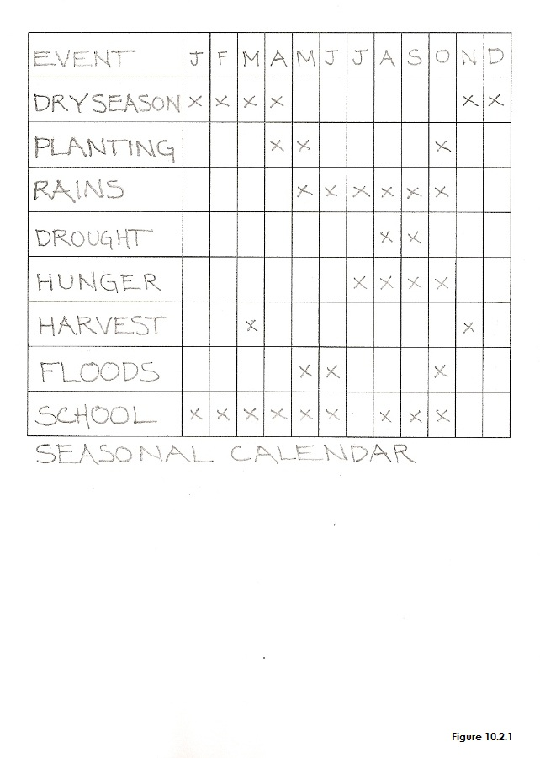 | 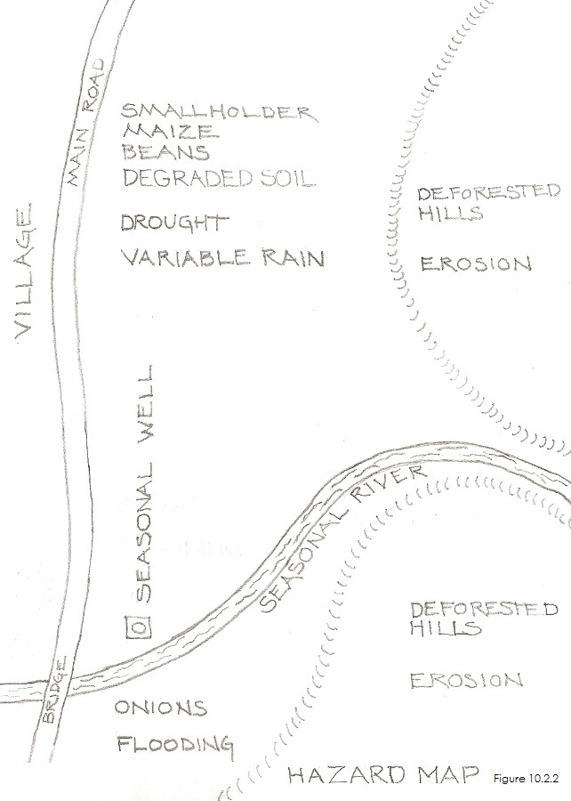
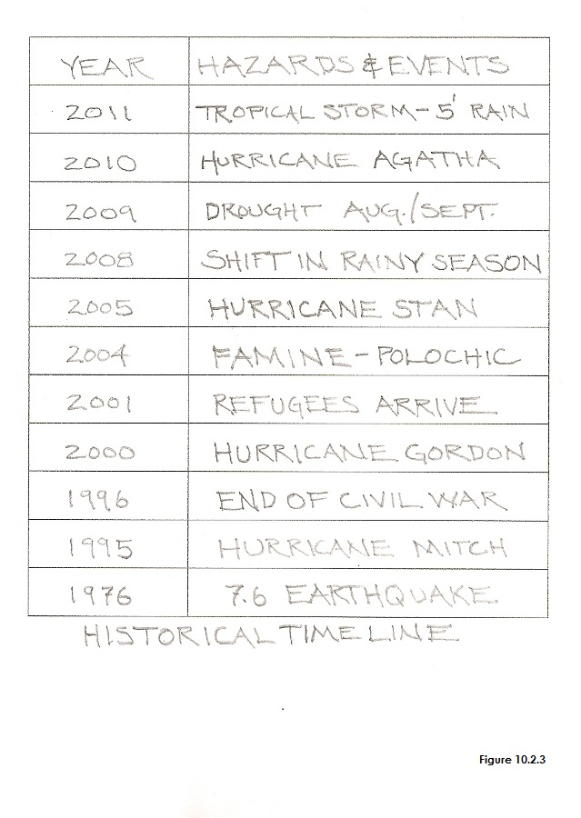 | 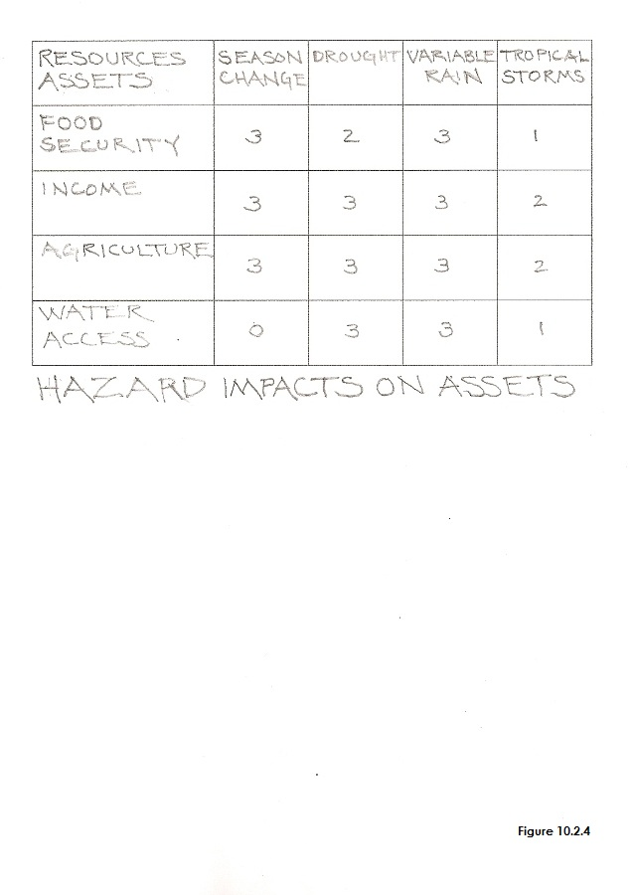
Copyright © Tim Magee

