Student Title: Bartel, Primus OL 344 Assignment 8
Student Date: 05 November, 20122012
Online Learning: Online Learning: OL 333 Climate Smart Agriculture.
Center for Sustainable Development http://www.csd-i.org/

Use this document as your template for your assignment.

Assignment Eight. Leading a participatory workshop in a climate smart agricultural technique
Part 1
Preparation for the workshop began the week of 28th October 2012, a week in advance because we realized that we needed to get more materials (like paper and markers and a stand to hold the paper) and we needed to develop the how-to card to give to the participants, and a few simple posters to illustrate some of the ideas that we're going to discuss in the workshop.

Time was also needed for me to verify that my three colleagues that usually assist me will be available to offer support during the workshop, and for us to make arrangements for the provision of some snacks and a luncheon. During the workshop my colleagues will make sure that all the participants are fully involved and their contributions will be included.

The community is now very far away, however we decided to spend the latter part of Friday 2nd November 2012, in the community to ensure that the room was set up for the workshop and the demonstration plot was cleared and ready, Mr. Mahon had asked that it be divided into two portions. Also that the mulching materials were readily accessible and the necessary tools on hand. We also spoke with the agricultural extension officer – Mr. Mahon to ensure that he was still available for the next day’s session.

Thus far we have given a lot of workshops but were really glad for the lesson plan my course partner Hanna had developed. It helped us tremendously get started and to keep us on focused and on track..

We tried to be as inclusive possible to make the process as participatory as possible and to get every member of the community involved. As is usual with these types of workshops we are certain that we would also gather pieces of information that we hadn't known before.

The workshop was about soil restoration and conservation for smallholder farmers. Our team was joined by the agricultural extension officer that we usually work with and had worked with us on the participatory mapping workshop—Michael Mahon

We started the workshop off with an icebreaker just to get everyone relaxed and their minds off of their immediate individual problems and into a group spirit. We then did quick introductions—everyone had met each other but in some situations hadn't seen each other for a while.

The workshop began with a conversation about why they, the farmers need to restore and conserve their farms soil—and then we discussed low-cost/no-cost activities that they could do beginning today.

And based on Tim’s example we asked Mr. Mahon to speak in “layman’s language” on what soil is made of, its composition, types and characteristics with emphasis on clay soil, organic matter, nutrients, and beneficial flora and fauna.

Mr. Mahon then demonstrated some very simple hands-on soils tests that we all did together that allowed us to see what the makeup of their soil was (we asked each farmer to bring a little can of typical soil from their farm field). This let them see what the condition of their soil was in, how much loam was left after erosion, and how much organic material as well. We then looked at examples of different kinds of organic materials that are available in and around the village. These range from crop residues (in this case the stalks of the pigeon peas and corn plants), to leaves, animal manure, and to grasses.

Mr. Mahon in discussion with us had decided that the ideas presented in Tim’s example project was appropriate and as a guideline was suitable, so he would just follow the outline.

Hands On Demonstrations:

Mr. Mahon then did the demonstration where he divided a part of the plot of soil into 4 squares. The participants also with Mr. Mahon lined the edges of one with bricks and placed a piece of glass on top, sprinkled a thin layer of mulch on the second one, sprinkled a thick layer of mulch on the third square—and left the fourth square bare. We returned an hour later to look at how hot the surface of the soil was in each of the four squares—and what the level of soil moisture was and then had a very lively discussion about the results.

After lunch we then began the session on composting by building a compost heap with materials that we had put on site before the workshop—all the while discussing what compost was, how to make it, and what its benefits were.

The day before we had a couple of farmers prepare half of the demonstration plot the way they usually do for planting. We then demonstrated a conservation agriculture approach in the second half of the plot and created deep bedding with gullies between them. In this final exercise the farmers planted their half and we planted the other. The farmers plot was left bare (as they would normally do) and we covered our plot with mulch. We had allocated an hour and a half to do this so there would be plenty of discussion about why we were doing what we're doing and what we hoped would be the outcome; this session went on for two hours and we had to actually let the farmers know that there were other sessions to be done. The demonstration plot will be monitored over the next few months to see how the two planting techniques compare with each other.

We thank had some refreshments and a long, cold drink and began the next step of the workshop, to discuss what was previously done and what was learnt and how:
- depleted soils can be restored with the addition of organic material and compost
- restored soils have increased nutrients and flora and fauna—and a greater ability to retain moisture
- restored soils can be conserved by applying mulches
- mulches reduce evaporation and contribute organic material and nutrients to the soil
- clay soils could be made more arable with the addition of organic material, sand and fine rocky particles

The workshop concluded with participant feedback. All in all, everyone thoroughly enjoyed the workshop. There were many animated discussions and everyone was excited to follow up on the demonstration plots.

It took us until 7:00 pm to finish the workshop and have our wrap-up discussions. So, the workshop actually took 10 hours (if you deduct the time for lunch), we began at 8:00 am as the farmers wanted to begin before the heat of the day.

My colleagues and I took photographs and in the process of taking them we looked at them on the back of the camera to make sure that they were of good quality, they were in focus, and that we had a variety of different kinds of photographs.

We took notes on how things were going, what was working and what wasn’t and we also kept track of how long each of the exercises took for future reference. My colleagues were wonderful and made sure everyone was included at all times.

Monday (today actually) the team and I got together and reviewed the workshop and made notes that would help us to do a better job the next time we give it.

We all felt that the lesson plan was well done and we didn't have any improvements that we would recommend – good job Hanna. We however recommend that we conduct this workshop in two days instead of one to allow for more feedback and discussions.

We all agreed that the workshop was a success.

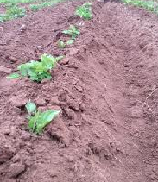
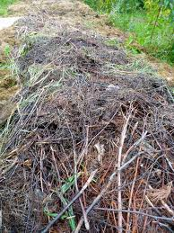
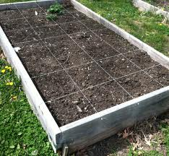
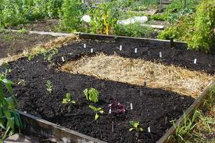
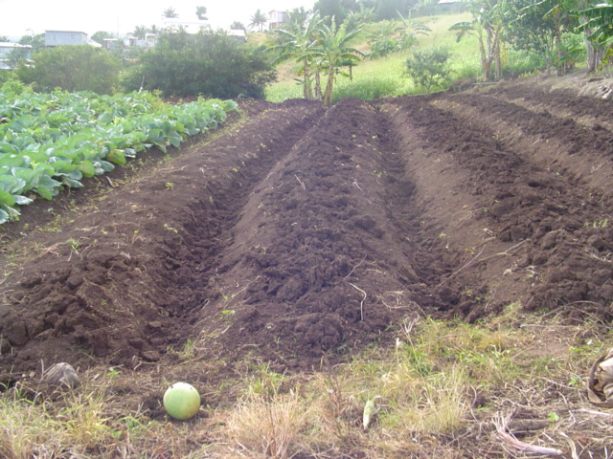
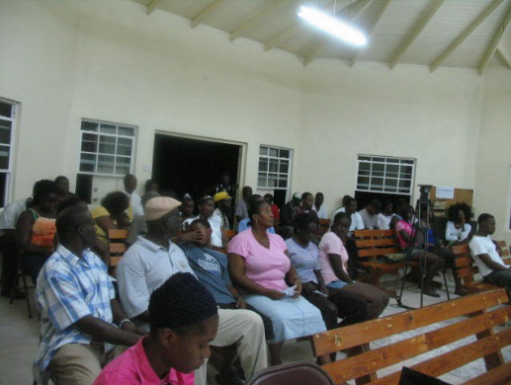
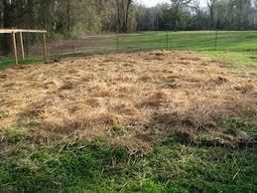
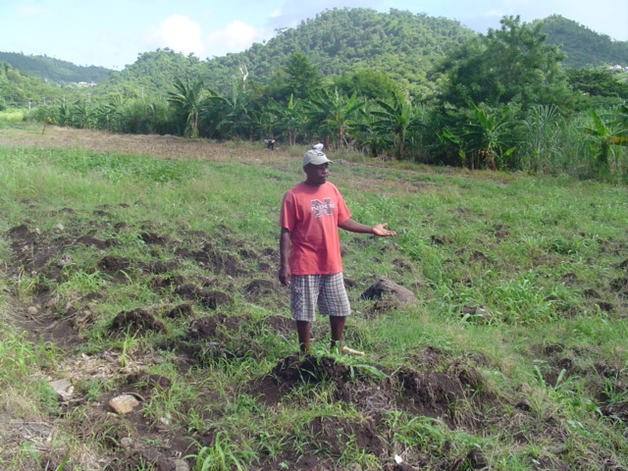
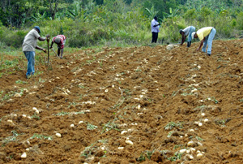
Deep bedding planted with sweet potatoes – un-mulched
Stalks from pigeon peas plants to be added as organic material to soil
Plot division to experiment with soil temperature and moisture content
Demonstration plot cleared and deep bedded – left without mulch for planting
Farmers at the end of a very long day
Mulched area to be planted
Demonstration plot before been cleared
Hard at work

