Student Title: Enns Gheorghe OL 343 Assignment 6
Student Date: September 20
Online Learning: OL 343 Adapting to Climate Change: The Community Focus
Center for Sustainable Development: http://www.csd-i.org/

Assignment 5 Part 2.
Since the previous workshop in Wagete did not include the vulnerability matrix exercise, it was conducted last week with Philip’s visit to Wagete before he proceeded to have the discussion related to Assignment 6. His report is below.

Africa Inland Church Tanzania - Diocese of Mara and Ukerewe (AICT-MUD)
Field report for facilitation of preparation of the vulnerability matrix for Wagete village
The meeting with Wagete group members was done on 16th September and the objectives for this visitation together with other program objectives, the following objectives were included
- Develop the Vulnerabilities matrix for Wagete village
- Discuss their thoughts and what they learned from the workshop we did together with them
- Introduce the topic of the next workshop – setting up a community management committee to help us improve their adaptability to climate change
- Choose a rough date for the next workshop
Developing the vulnerability matrix
The facilitation started by asking the group members to identify their most important livelihoods resources tha they consider to be most important in achieving their well-being. They came up with a list of them as shown below
- Livestock farming
- Crop farming
- Education especially for their children
- Small business
- Health services
Then after this list was identified, the facilitator asked them to identify the greatest hazards to their livelihoods. This was a bit simple exercise because they had already identified the hazards in the last meeting; so their task was to identify among those hazards, which had serious impact to the identified livelihood resources. The hazards identified were as follows
- Droughts
- Floods
- Poultry diseases
- Human diseases (TB, Malaria and HIV/AIDS)

After all that, the facilitator asked group members to rank the vulnerability of each identified resource from each of the identified hazard by using the ranking numbers as follows

- significant impact on the resource
- medium impact on the resource
- low impact on the resource
- no impact on the resource

The resulting matrix was as follows
Most important livelihood resources |  | Most dangerous hazards
Most important livelihood resources |  | Droughts | Floods | Poultry diseases | Human diseases (TB, Malaria and HIV/AIDS)
Most important livelihood resources | Livestock farming | 1 | 2 | 1 | 1
Most important livelihood resources | Crop farming | 1 | 1 | 4 | 1
Most important livelihood resources | Education services | 1 | 2 | 2 | 1
Most important livelihood resources | Small business | 1 | 3 | 3 | 1
Most important livelihood resources | Health services | 1 | 2 | 2 | 1
The original matrix and the respective ranking style are shown in the photo below which was taken during the exercise
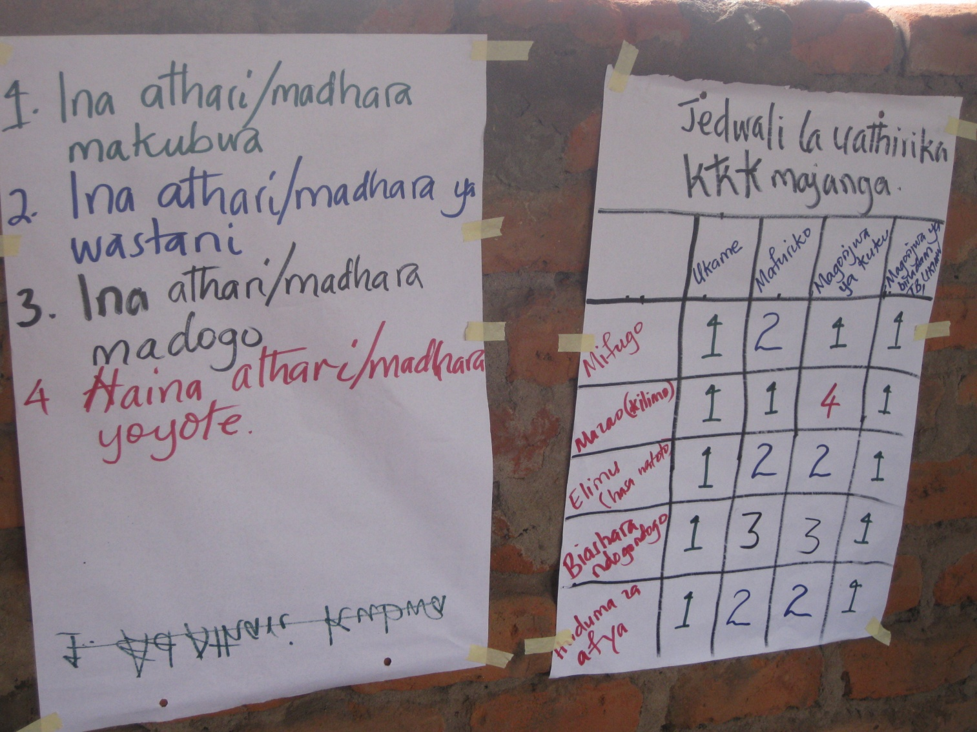
The photo below was taken when the community members were observing the summery of how vulnerable their livelihood resources are to the climatic hazards displayed in the matrix form.
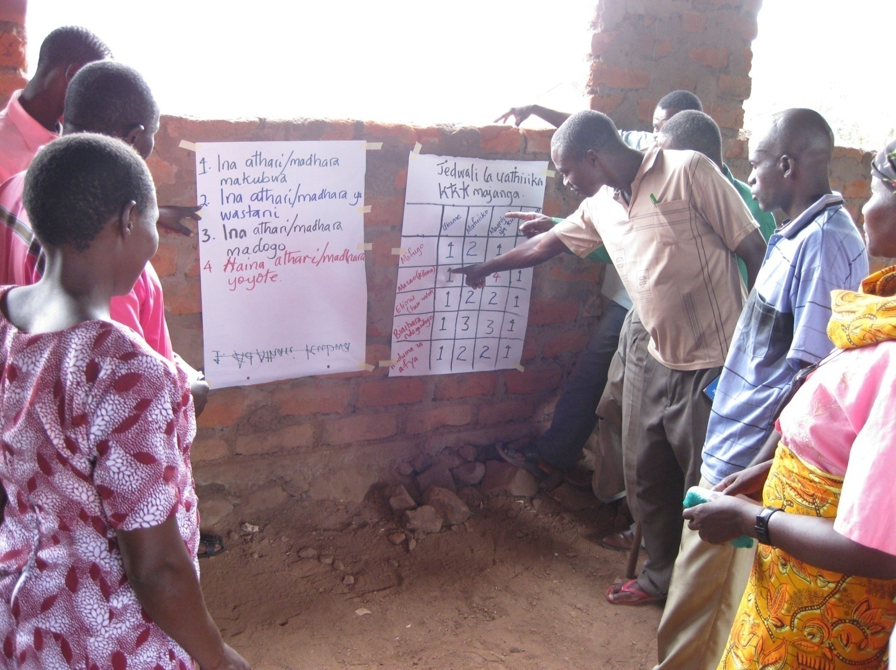

Assignment 6.

Part 1: Incorporating your project refinements into your management documents.

Our existing log frame and the planned activities do a good job of responding to the expressed needs of the community from the workshop so we don’t feel that we need to add anything.

We then modified the budget and timeline to reflect the greater amount of detail and timing that we now know about the project and the community.

Part 2: Feedback and Ownership

Discussing people’s thoughts and lessons learned from the last discussion
The discussion of the lessons learned from the previous workshop showed that people were very happy with the analysis of the impact of climate changes in Wagete village. The lessons they learned include
- The importance of discussing together on the issues facing the community. They testified that it has been great to have such discussions because some important issues like lack of health services that has been facing the village for a long time was addressed during those discussions.
- Significance of having collaboration with other development practitioners in addressing community problems. They really appreciated the fellowship with AICT-MUD and CRWRC for provoking such discussions
With these lessons, they insisted that we should continue working together in making sure that the issues addressed are dealt with accordingly especially the issue of lack of health services which has been a burden to the people for a long time.

Part 3 Pre-preparation for the Leadership Workshop

Introducing the topic of the next workshop and dates
The facilitator introduced the topic of forming a community-based management committee which will be discussed in the next workshop and the community members were grateful and eager for it. On setting the dates, they said it should be done in October but the responsibility of arranging the specific dates was left in the hands of AICT-MUD and CRWRC depending on the staffs working schedules. The exact date will be determined when Philip from AICT and Chris from CRWRC will meet together at the end of September to plan this workshop.

