OL 332 A7 Field Guide: Community Level Watershed Management.
Tim Magee

Developing community watershed management as a component of a master water use management plan.
A shortage of water or unreliable access to water is one of the biggest issues in development. Community water sources dry up during climate change related drought—or seasonally during the dry season. There is competition among different segments of the community for available water. Discussing community water harvesting calls for stepping back from the immediate problem and looking at the relevant underlying causes for the shortage of water in order to begin developing solutions.

Community based water management committees. Forming a water management committee is the initial step in developing a water management plan. A committee can provide direction, consistency, management, regulation and enforcement.

The first step in forming a water management committee is to introduce the concept in a participatory workshop setting; ask your community contacts to approach community members about participating in a water management workshop. In the workshop you can begin by introducing the rationale and importance of having a community based water management committee who can develop a plan for improving access to water.

Discuss the types of skills that will need to be developed by committee members. Suggest appointing an interim committee who over the course of six months could develop the ultimate committee, establish management responsibilities, ensure gender inclusiveness, set goals, and initiate the planning process. Ask the workshop participants to decide on the number of people that should serve on the committee—and then ask if there are members who would be interested in sitting on the interim committee.

Water use management plan. The first step in developing a water use management plan is to better understand what knowledge community members have about water resources and water use. A simple way to do this is to hold a participatory mapping workshop to look at the community's water resources, distribution, uses, and weather related challenges. Field Guide 5 tells how to do this first step.

Having identified the community’s sources of water, how the water is distributed, how the water is used, when there's too much water and when there's too little water, you can begin the process of developing a plan which would include:
1. Consulting with a water management expert to develop a participatory training and planning program.
A water management professional will be able to help the community assess their unique situation and propose solution oriented activities appropriate for community context, capabilities and resources.
2. Prioritizing which challenges to approach first.
The challenge of not enough water could be due to unequal allocation, deforested catchment areas, existing infrastructure that is in disrepair, or it could be that new, alternative sources have not been explored. In the community's existing context, determine which challenge, if solved, will give them the greatest increase in water access at the lowest cost.
3. An investigation into the restoration of environmental services.
If the watershed around the village has been deforested over time, it's possible that rainwater simply runs off the hillsides rather than infiltrating into the soil and recharging the local water table. The water management expert can help with this determination and help develop a plan for reforestation.
4. An investigation of water sourcing alternatives.
The best alternative may be to look for new sources of water. This could include a new well, or it could include water harvesting structures to channel water to a community storage reservoir.
5. The development of an infrastructure installation, maintenance, and repair program.
Two of the main reasons why water systems fail over time is that they weren't designed by experts and they weren’t maintained by the community. A sustainable water use management plan needs to take into consideration expertise in both design and installation oversight, and a plan for funding and implementing routine maintenance.
6. The development of a water allocation plan.
The community may have sufficient water but a wealthy farmer or nearby factory may be using more than their share. Developing an advocacy plan to approach the local government can begin the process of creating an allocation plan which is fairer to the community. An allocation plan will also ensure that new community water resources are distributed fairly among different segments of the community.
7. Compile these steps into a comprehensive water use management plan.
Completing these steps could take a year or more but when they are done, they need to be compiled into a master water use management plan. The water management committee should be in charge of overseeing the development of the plan's components, of collecting water use fees, and of enforcing the plan.

The water challenge. Here is an example project detailing water challenges and solutions that are typical in rural settings. During the course of their investigations a water use management committee determined that deforestation of the hilly watershed behind the village has led to rainwater runoff that causes soil erosion, the creation of gullies, siltation of the main stream bed, and occasional flooding in the village during heavy rain. The downhill movement of rainwater is no longer slowed by trees and undergrowth; it no longer slowly infiltrates into the soil and recharges the local groundwater system. This is evident in the fact that the village well and the streambed are frequently dry.

The water management plan. The committee decided upon a triple plan: a soil and water conservation program in the watershed, a reforestation program for the watershed, and the construction of a subsurface dam in the dry streambed adjacent to the village well.

With the help of a watershed management expert, a more detailed map was drawn of the village's watershed showing where rivulets and gullies direct rapidly flowing rain water away from the watershed. The expert suggested locations for 12 check dams on these gullies—and said they should be the first step. Their purpose is to slow the velocity of water movement thereby reducing erosion and allowing water to infiltrate into the soil.

Water infiltration will recharge local groundwater systems and provide soil moisture for the reforestation program. A reduction in runoff from heavy rains will reduce flooding in the village. Over time, soil accumulating behind the check dams will begin the process of filling in the gullies.

The plan is to start a tree seedling nursery of native trees, and at the same time begin the construction of the 12 check dams. The villagers are concerned about building the subsurface dam near the village until the check dams have been put in place; they don't want the subsurface dam to wash away during a flood if the check dams are ineffective. They have time now to build the check dams before the next rainy season—and they will have tree seedlings to plant alongside the gullies and rivulets when the rainy season begins. If their check dams are successful and the village doesn't flood, then they will feel comfortable building the subsurface dam in the riverbed at the beginning of the next dry season.

Because of the expense and engineering requirements of concrete check dams the community decided to experiment with very simple, inexpensive check dams to ensure that they were going to be effective. Two kinds of check dams were chosen: loose stone and brushwood. They are semi-porous: some water will pass through them and reduce water pressure build up. Consequently the engineering requirements are minimal. Rainfall conditions, terrain and building materials vary from location to location, and the check dam expert helped the community members decide the size and configuration of their dams. Three workshops have been planned. A one-day workshop to build a brushwood check dam, and a two-day workshop to build a loose stone check dam. These check dams will be made of locally found materials. If effective, these low-cost check dams could be replaced over time with more permanent structures.

Brushwood check dams. A brushwood check dam is a framework of vertical posts sunk 1 meter into the ground .5 meters apart. Two parallel rows of these posts are placed .5 meters apart. These types of dams are rarely more than 1 meter high and the catchment area should be 1 hectare or less. The first step is to clear the dam’s location in the gully of brush and loose soil. Cut a slot 30 cm deep into the walls of the gully. Dig a series of 15 cm diameter holes for the posts a meter deep with a post-hole digger. Ram the posts vertically into their holes and pack dirt around them so they are rigid. Cut brush or branches 2 or 3 cm in diameter into 65 cm lengths. Tie them into bundles 15 cm in diameter. Do not place these bundles directly on the ground, but on a bed of straw or mulch to prevent erosion under the brushwood. Place them in layers inside of the framework making sure each layer is well compacted. Every second layer, cross stays should be tied to the vertical posts connecting the two rows of posts. The bundles should penetrate the walls into the 30 cm deep slot and anchor the dam. The top of the check dam should be curved with a low section in the center for water to spill over if the check dam fills up. Bundles of sticks should cover the ground on the downhill side of the dam so that soil below the dam won't be eroded.

Loose stone check dams. Typically, these types of dams are rarely more than 1 meter high and the catchment area should be 2 hectares or less. The first step is to clear the dam’s location in the gully of brush and loose soil. The second step is to dig a 30 cm deep trench beginning at just below the top lip of one bank progressing across the bottom of the gully and extending to just below the top lip of the opposite bank. This will allow the stone dam to be anchored in position. The highest point of the dam should be lower than the surrounding land to prevent flooding of adjacent fields. The base of the dam should be wider than the top—so the walls slope inwards from the base towards the top. The first layer of stones in the trench act as the anchor; this layer of anchor stones will be one stone width wide. The next layer of stones should be three stones wide and after several layers narrow to being two stones wide as it rises to the top. The top of the check dam should be curved with a low section in the center for water to spill over if the check dam fills up. A layer of stones should cover the ground on the downhill side of the check dam so that soil below the dam won't be eroded as water spills over the top.

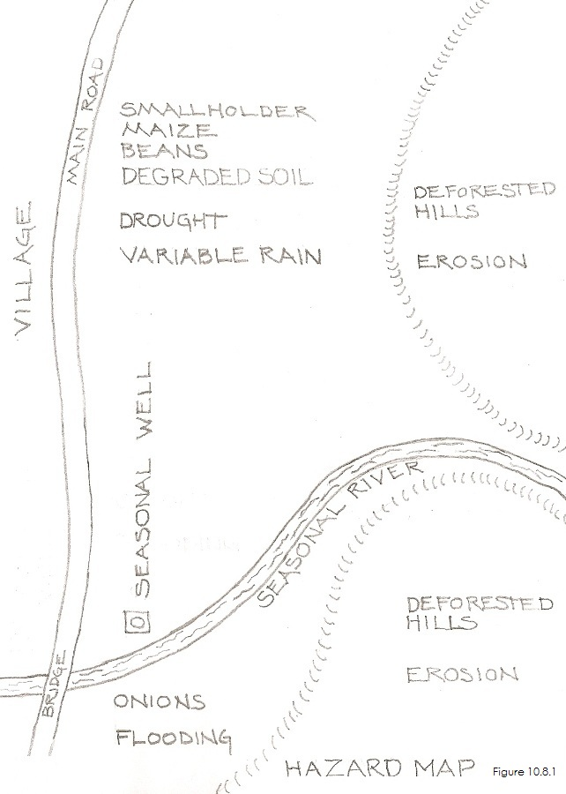 | 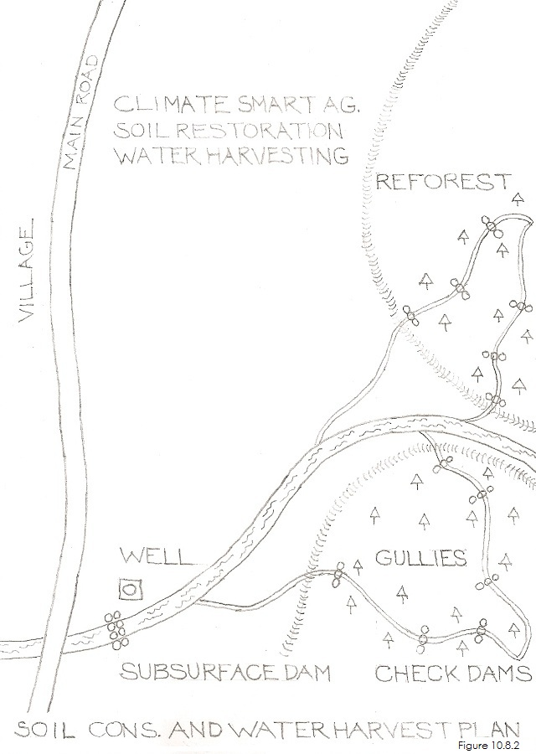
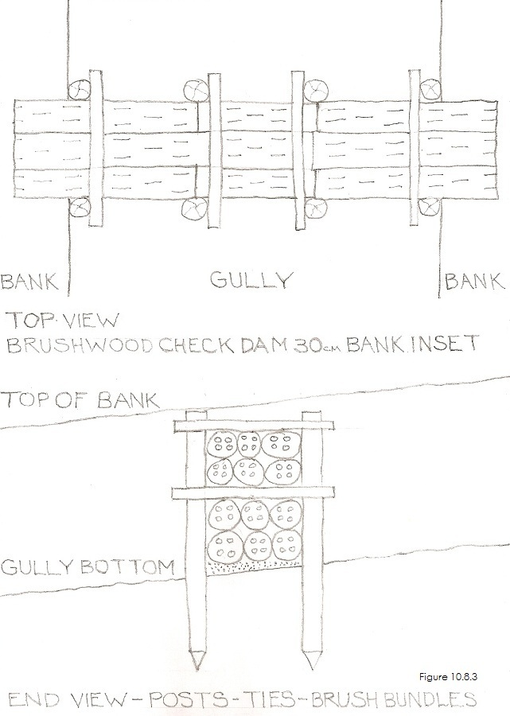 | 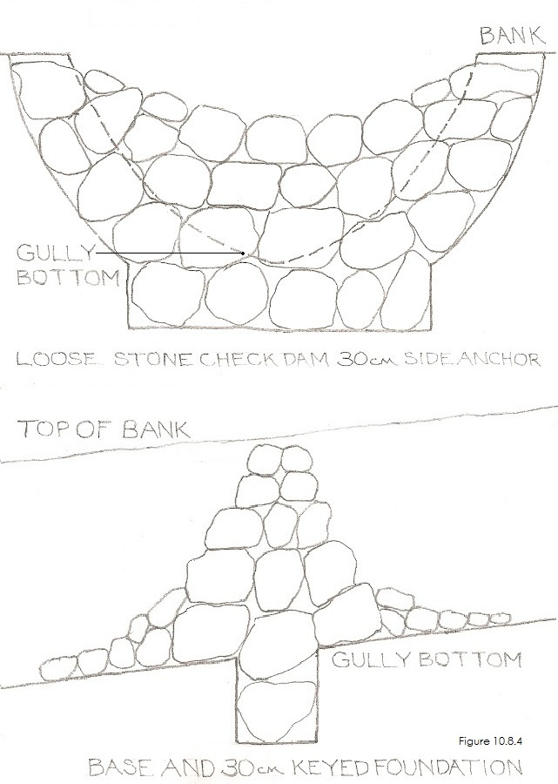

OL 332 A7: Workshop Lesson Plan for How to Build Check Dams.
3 days (can be completed in three one-day workshops or six 1/2 day workshops)
PURPOSE: What workshop participants will be able to do as a result of the lesson.
Objective 1: Participants will understand the benefits of a building check dams.
Objective 2: All will understand the basic design components and appropriate materials for use in construction.
Objective 3: Participants will know how check dams can reduce loss of topsoil and recharge groundwater.
Objective 4: Participants will know how to construct and maintain two kinds of check dams.
MATERIALS
- Artist’s drawings/posters; the scenes and people they contain should appear familiar to workshop participants.
- How-To Cards without written words for workshop participants to take home.
- Large sheets of newsprint and tape. Colored markers.
- Tools for installing the check dams including picks, shovels, sledgehammer, brushknife, and galvanized wire.
- Stones for the loose stone check dam, and posts and brush for the brush wood check dam
PREPARATION
- Identify a gully in need of restoration close to the village.
- Deliver sufficient stones for building the stone check dam to the site before the workshop.
- Deliver posts and sufficient cut brush for the brushwood check dam to the site before the workshop.

BEGINNING OF LESSON:
Activity 1. 40 minutes (including a 15 minute ice-breaker). Introduction to the benefits of check dams
Purpose: Participants will understand the challenges of deforestation and opportunities for restoration.
What to do
- Ice Breaker: Introductions. Sing a song or play a game.
- Introduction to workshop: Tell the participants what they’ll be able to do as a result of the lesson.
- All will learn deforested hillsides (the watershed) can lead to topsoil erosion, gullies, flooding, and a loss of groundwater.
- They will learn the loss of groundwater can mean that streams and wells dry up.
- All will learn that watersheds can be restored to reduce runoff using several systems—one of which are check dams.

Workshop Participants:
Have participants talk about what they do and don’t understand, what they do and don’t like.

Activity 2. 15 minutes. What check dams do
Purpose: To understand how check dams work.

What to do
- Discuss how a low wall placed across a rivulet or a gully will slow down the movement of water during heavy rain.
- This allows water to infiltrate into the soil—recharging groundwater that charges their wells.
- Slowing runoff allows eroded topsoil to collect behind the dam restoring the landscape.
- Check dams can be solid concrete dams—or semi-porous dams that allow some water to pass through.
- Porous dams such as loose stone dams and brushwood dams are less expensive to build and require less engineering.

Workshop Participants:
Have participants talk about what they do and don’t understand, what they do and don’t like.

Activity 3. One day. Building a brushwood check dam
Purpose: To understand how to build a brushwood dam.
What to do
- Show the participants how the site for building the dam was chosen.
- Have one team begin digging a slot 30 cm deep by 50 cm wide into the walls of the gully.
- Have another team begin digging 15 cm diameter holes for the posts a meter deep in two rows 50 cm apart.
- The 15 cm diameter posts should be cut to be approximately 2 m long and then pointed at one end.
- Have one team begin pounding the posts into the holes with a sledgehammer and then tightly packing soil around them so that they are vertical and rigid.
- Have a second team take the cut brush and cut off the twigs leaving 2 or 3 cm diameter sticks 65 cm long.
- Make 15 cm diameter bundles and tie the bundles with sisal or wire.
- Lay straw or other dry mulching materials on the ground at the bottom of the gully between the two rows of posts.
- Begin putting the bundles in between the parallel posts and compressing them in place making sure the ends of the bundles are inserted into the 30 cm deep slots in the gully walls in order to anchor the dam in place.
- On top of every second layer cross stays should be tied to the posts to structurally connect the two rows of posts.
- The top of the check dam should be curved with a low section the center for water to spill over.
- Bundles of sticks should cover the ground below the dam so the soil at the bottom of the dam won't erode.
Workshop Participants:
Have participants talk about what they do and don’t understand, what they do and don’t like.

Activity 4. 20 minutes. Maintenance
Purpose: To learn the steps involved in maintaining and repairing a check dam.

What to do
- The dam should be checked before the beginning of the rainy season to make sure that there aren’t gaps.
- Posts and sticks that have rotted should be repaired or replaced.
- The area below the dam should be checked to make sure that there are sticks on the ground to prevent erosion.

Activity 5. 30 minutes. Conclusion
Purpose: To review the brushwood check dam system and provide feedback.

What to do
1. Reinforce the benefits of check dams.
2. Review the basic design components and appropriate materials to use for construction.
3. Review how check dams can reduce loss of topsoil and recharge groundwater.
4. Verify that workshop participants are comfortable that they can build a brushwood check dam.

Workshop Participant Feed Back:
Have participants talk about what they do and don’t understand, what they do and don’t like.

Activity 6. Two days. Building a loose stone check dam
Purpose: To understand how to build a loose stone check dam.

What to do
- Show the participants how the site for building the dam was chosen.
- The highest point of the dam should be lower than surrounding land to prevent flooding of adjacent fields.
- Have one team begin digging a 30 cm deep by 40 cm wide anchor trench starting just below the lip of one of the walls of the gully, continuing along the ground and then continuing to just below the lip of the opposite wall of the gully.
- The trench will anchor the check dam into position.
- The base of the dam should be wider than the top so the walls slope in from the base towards the top.
- Lay a single row of stones in the foundation trench.
- Then lay three rows of stone above the foundation stones and begin building the wall up.
- The wall should slowly become narrower as it rises and only be two stones wide at the top.
- The top of the check dam should be curved with a low section in the center for water to spill over.
- More stones should cover the ground below the dam so the soil at the bottom of the dam won't erode.

Workshop Participants:
Have participants talk about what they do and don’t understand, what they do and don’t like.

Activity 7. 20 minutes. Maintenance
Purpose: To learn the steps involved in maintaining and repairing a check dam.
What to do
- The dam should be checked before the beginning of the rainy season to make sure that there are no gaps.
- Missing stones should be replaced
- The area below the dam should be checked to make sure that there are stones on the ground to prevent erosion.

Activity 8. 30 minutes. Conclusion
Purpose: To review the loose stone check dam system and provide feedback.
What to do
1. Reinforce the benefits of check dams.
2. Review the basic design components and appropriate materials to use for construction.
3. Review how check dams can reduce loss of topsoil and recharge groundwater.
4. Verify that workshop participants are comfortable that they can build a loose stone check dam.

Workshop Participant Feed Back:
Have participants talk about what they do and don’t understand, what they do and don’t like.
Copyright © 2012, Tim Magee. All rights reserved.

