Families of the Margarethaplantationbenefit from a sustainable livelihood through drainage and sanitation, water management and flood mitigationefforts.
A two-page project summary for UNDP Suriname and Suriname Red Cross.

COMPELLING NEED
Imagine you arethe head of a distressed family whose home is damaged by a recent flood.

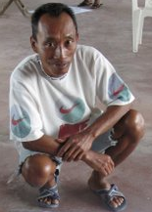
If you live in a plantation along the coastal area of Suriname, you are likely a subsistence fisherman, with a secondary school education. Increasingly harsh weather conditions disrupt your daily fishing activities, reducing harvest and incur further emotional tensions in the family. On top of this, your home gets damaged from the intrusion of sea water during heavy rainfall periods. This problem, exacerbated by a lack of knowledge of risk, vulnerability and coping techniques for flood and water management negatively impacts your family: a damaged home, reduced harvest from fishing activities and poor soil fertility leads to a distressed family and possible chronic illness and malnourishment. This not only impacts the family but over the longer term, it impacts the livelihood and the atmosphere of the entire community.

APPEAL FOR FUNDING
$18,000.00 will help this community of 100 families in the community of the Commewijne districtsecure asustainably livelihood.
Your financial support of $18,000.00 will not only help Community Development Institute of Suriname (CDIS)educate the 100 families of the Margaretha plantation in risk, vulnerability and coping techniques for flood and water management, but also, concurrently engage and support the community in putting in place the necessary longer-term plans including a Rainy Season Drainage and Sanitation Master Plan, Water Management Plan and Community-Based Flood Mitigation and Adaptation Program as well as setting up community-based committees to drive and implement the necessary efforts. The community will ultimately become one that is empowered and that is capable of taking charge of building themselves a secure and sustainably livelihood.

ABOUT YOUR ORGANIZATION

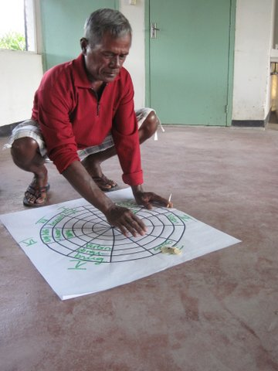

Why invest in theCDIS?
CDISisa local non-profit organization set up by two young, aspiring entrepreneurs who are committed to the idea that responding to community-identified needs with accessible technologieswillbring about sustainable, long-term change for families and change that sets a positive example community-wide.

CDIS’s approach to development is characterized by long-term development, rather than short-term relief.At CDIS, we believe in working hand-in-hand with government, governmental agencies, other NGO’s and other stakeholders in helping communities become more sustainable.

CDIS works to prioritize community-identified needs and researchesscience-backed, solution-oriented activities that work to solve problems. CDIS’s programs will include workshops customized to the needs of the community and issue at hand and relevant support to help communities set up the necessary governing structures as well as immediate, mid-term to long-term plans.

HOW YOU PLAN TO SOLVE THE PROBLEM
This Proposal: Sustainable livelihood through drainage and sanitation, water management and flood mitigation
efforts.
With this proposal, CDISwants to help 100 families take responsibility and be empowered to build themselves and their community a brighter future through:
- ARainy Season Drainage and Sanitation Master Plan that includes workshops to educate the community of their needs for drainage facilities and to support the setting up of a committee as well as engagement with relevant experts and donors on a drainage and sanitation master plan.
- AWater Management Plan that includes workshops and training programson water management and water related challenges, support for the formation of a committee and the development of a water management plan.
- A Community-Based Flood Mitigation Program that includes workshops to educate the community on risk, vulnerability, and traditional coping techniques for floods, support for the formation of a committee as well as the development of a risk reduction and flood and preparedness plan.

MEASUREMENT OF SUCCESS
How do we know our programs will work?

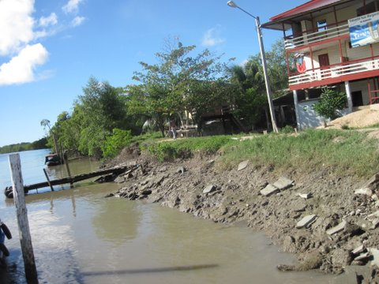

Studies have shown that the implementation of long-term community-based safety programs in experienced communities with disasters presents significant benefitsincluding the reduction of costs, as well as the cost of social dislocation and psychological distress that occurs when vulnerable communities are exposed to a disaster.Various researches have also revealed that in many cases, communities still need additional information in order to minimize their vulnerability to disasters such as flooding. Some researches recommend the implementation of planned adaptation options such as changes in water-use management policies and appropriate infrastructure investments.

BUDGET NARRATIVE
CDISis requesting an amount of $18,000.00from UNDP and Red Cross Surinamefor this 30-month project that will improve the lives of 100 families of the Margaretha plantation. The funds will: i) provide workshops to increase the communities understanding in drainage and sanitation, water management and water related challenges, risk, vulnerability, and coping techniques for floods, ii) the required support to form the relevant community-based committees to drive the necessary initiatives and iii) the support required to engage relevant experts and donorson the various long-term plans to ensure a sustainable livelihood for the community. The community will be engaged throughout the project to instill ownership and accountability. This will ensure sustainability of the efforts and build lasting impact to the community.

CONCLUSION
Overall, we believe that our program dovetails well with UNDP Suriname and Suriname Red Cross’ focus on risk reduction, adaptation to climate change, the environment and capacity building. By partnering with us,UNDP Suriname and Suriname Red Crosswill help 100 families achieve a more sustainable livelihood. The families will enjoy a more consistent harvest from their daily activities and a more stable and robust family life. Members of the family live in confidence knowing that the future will be one of hope. The children of these families will grow up to be confident, self-sufficient adults, fully capable of leading productive lives.
Please don’t hesitate to contact us with questions or to receive supporting documentation.

Sincerely,

Gaitrie Usha Satnarain
Executive Director
Community Development Institute of Suriname (CDIS)
gaitrie.s@cdis.org
www.cdis.org

