3096 family members from 387 families in the Malian village of Sodieni will be food secured and will live safer livelihoods.
A two-page project summary for the North-East Foundation (NEF), Mali

Imagine you live in a community where extreme poverty and hunger due to climate uncertainties frighten life.
Year after year, the suburban community of Sodieni in Mali runs short on food due to insufficient and erratic rainfalls. The unique pond which provides water to feed rice and other vegetables dries up prematurely before crops get ripe. This leads to recurrent famine and instable livelihoods of the community. At other times too heavy rains damage the harvest additionally. The runoff water moves the soils away to silt the pond. The lack of water and food causes youth to leave the community in search of more paying jobs in towns. As if this was not enough, the Government is depriving the community of Sodieni from their potential farmlands to be used for housing purposes. The future announces increasingly gloomy for the Sodieni community if nothing is done.
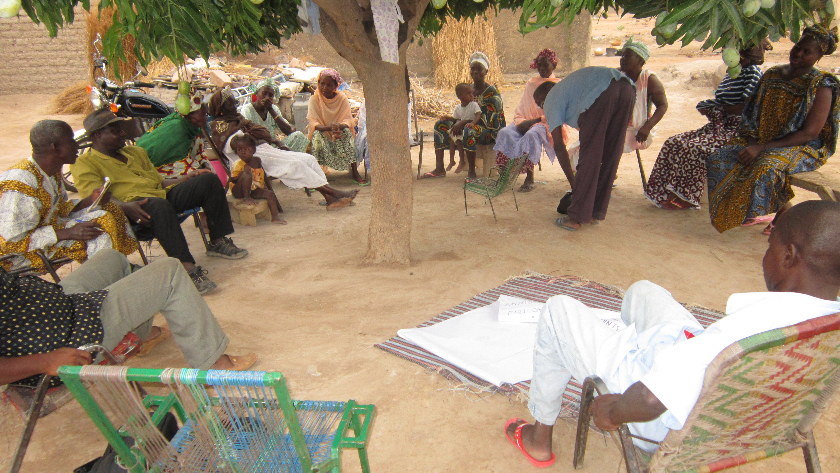

$26,800.00 will help3096 family members from 387 families in the Malian village of Sodieni to become food-secure and to live safer livelihoods.
Support from the NEF of $26,800.00 will help the AMEP (Association Malienne pour l’Epanouissement des Populations) organization implement a water use management program and a climate-smart agricultural practices and market-driven agriculture program for 387 families in the Sodieni community. The program will help their 3096 members become food-secure and wealthy enough to rise out of the extreme poverty and to engage in more productive lives.

Why invest in the AMEP Organization?
AMEP which is a Malian National Non-Governmental Organization (NGO) was established and registered by the Government of Mali in February 2008. AMEP works toward the sustainable human, economic and social well-being of Malians. AMEP specifically targets rural areas by building capacities at the grassroots’ level.
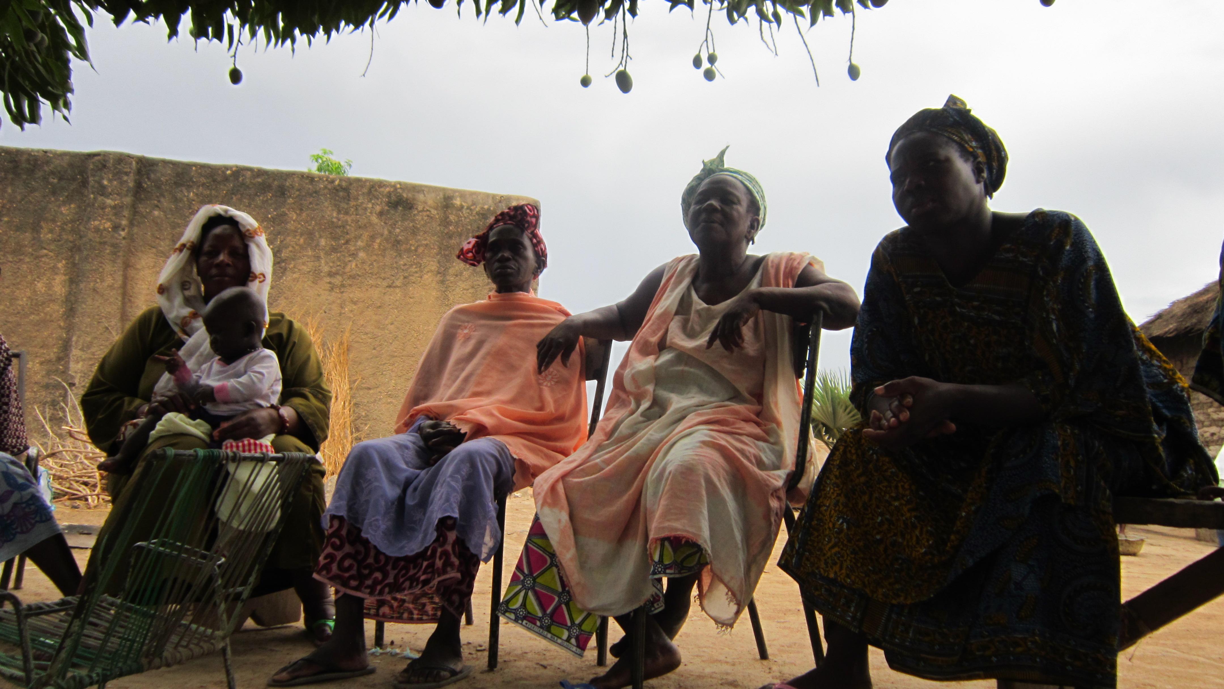
AMEP’s approach to development is “helping people help themselves”. The development incentives come from the communities themselves, and AMEP interfaces with support organizations and experts to accompany communities in their own development actions. AMEP educates targeted communities so they consider themselves as full potential partners for their own development, who need outside partners to address aspects which cannot be otherwise solved locally.

AMEP works to prioritize community-identified need and researches cost-effective and proven solution-oriented practices that work to solve problems. AMEP’s programs include needs assessment workshops, mapping and priority ranking exercises, resource identification, and action planning based on the principle of cost-sharing. AMEP has a strong follow-up and M&E program to make sure that beneficiaries are able to adopt the practices.

AMEP has long standing work relationships with Government agencies and many bilateral and multilateral donors. Since 2008, AMEP has supported many Malian rural communities gaining access to potable and gardening water, and has trained hundreds of farmers in the use of innovative agricultural technologies.

This Proposal: Food security and improved livelihoods through water use management, sound agricultural practices and market linkage project.
With this proposal, AMEP wants to help 387 families set an example and begin the process of rising out poverty through:

- A Water Use Management Program that includes workshops, supplies and follow-up on:
  - The establishment and training of having a water conservation and management committee in the village of Sodieni
  - The identification and proper use of alternative water sources for food production
- A Climate-Smart Agricultural Innovation Program that includes workshops, supplies and follow-up on:
  - The adaptation of food production systems to climate variability conditions
  - The behavior change with regard to development work
- A Market-Oriented Agricultural Development Program which also includes workshops, supplies and follow-up on:
  - The food production adapted to market demand, which promotes opportunities for more income and employment
  - The establishment of business relationships between market stakeholders and the community members

This will be an empowering program for these families.

How do we know our programs will work?
The program we are proposing here is essentially designed and directed toward achieving food security in the Community of Sodieni in Mali. We understand food security from the concept developed by the UN World Summit of 1996 which has determined food security to be a combination of three key dimensions: food availability, access and utilization.
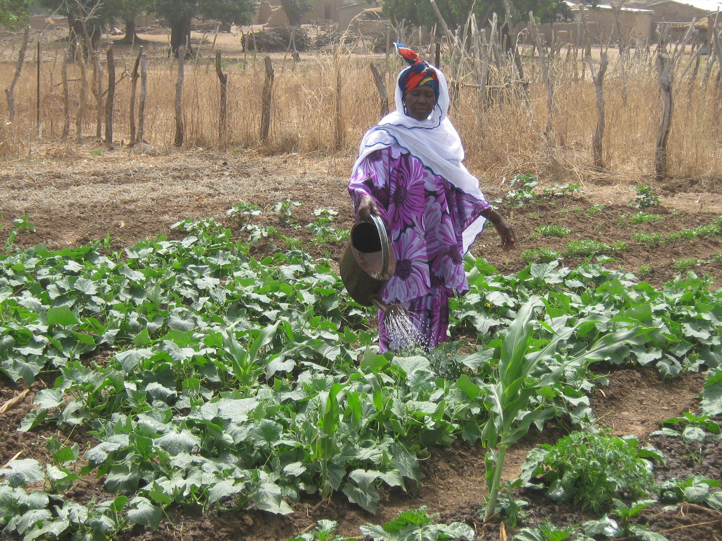
Food availability (supplies) increasingly depends on raising production per unit area of farmed land.
AMEP is going to support farmers in Sodieni so they are able to take up more sustainable, productive and profitable ways of production that do not damage the soil, land and environment, and which makes sound and efficient use of the limited water resources available. Together, AMEP and Sodieni farmers will seek out ways to maximize farmers’ income per hectare, while keeping the requirement for purchased inputs (improved seeds and fertilizers) low. In order to defeat the challenge of food availability, this project will build on local knowledge to introduce crop diversification and cost-effective innovative production techniques, including proper water use management plans.
By establishing business connections between Sodieni Community and the market dealers, this project will create opportunities for Sodieni community members to access more resources. The production on demand approach stimulates economic growth. As farmers produce on demand from the market, they will invest in more production technologies so to keep production increasing which enhances their own income. While doing that, they are able to provide adequate amounts of foods to feed their households. To take advantage from working in connection with business outlets, this project will encourage farmers to add more value to farm produces. This implies that farmers will learn to process, transform and pack properly their products in order to increase their income.
AMEP is requesting of the NEF $26,800.00 for this $37,400.00, 18 month project, that will improve the lives of 3096 people. The funds will provide 12 workshops in water use management, climate-smart agricultural techniques, and linking farmers to market for food-security and improved livelihoods. It will also include 100 demonstration plots including the purchase of improved seeds and the production organic fertilizers. Each workshop activity is reinforced by a follow-up program. AMEP will provide 28% cost sharing of $37,400.00.
Overall, we believe that our program dovetails well with the NEF’s giving priorities, especially those aimed at supporting indigenous Sodieni families. By partnering with AMEP, the NEF will help 387 Sodieni families improve their food security and their livelihoods. 3096 individuals will have access to sufficient amount of foods, employments, clean and production water. Their children will be able to attend school in order to embrace careers that will allow them to be contributing members of society and to lead self-sufficient, productive lives. This activity will ultimately lift Sodieni community out the extreme poverty to start building a brighter future for generations to come.

Please don’t hesitate to contact us with questions or to receive supporting documentation.

Sincerely,

Sissoko, Karim and Olabampe Ife
Promoters

